**Project 1: Deploying a website on AWS EC2 Instances**

**Virtual Private Cloud:**

**Steps:**

**1. In AWS console, search VPC.**

**2. In VPC dashboard, you will get my VPC’s and click on myvpc’s.**

**3. Click on create VPC. Select resource to create as VPC only.**

**4. Give name as anjana-vpc and IPv4 CIDR as 10.0.0.0/16.**

**5. Then click on create VPC.**

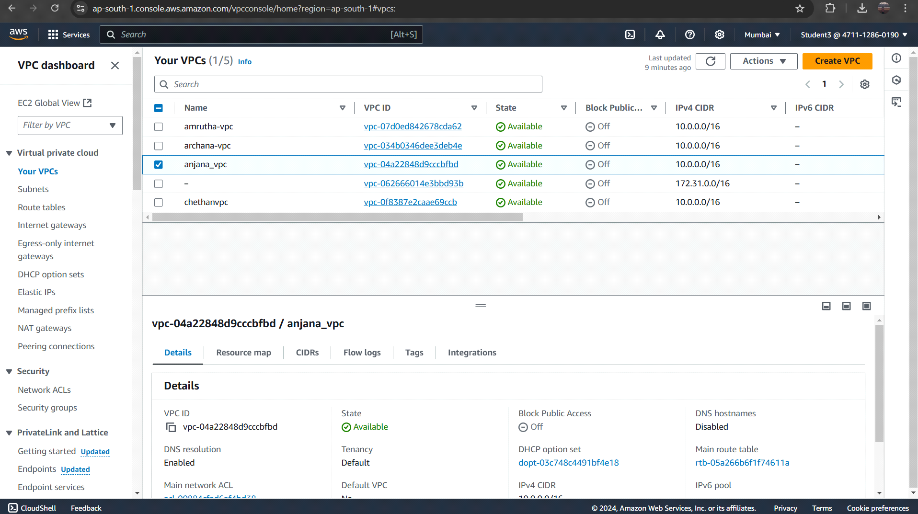

**Virtual private cloud:**

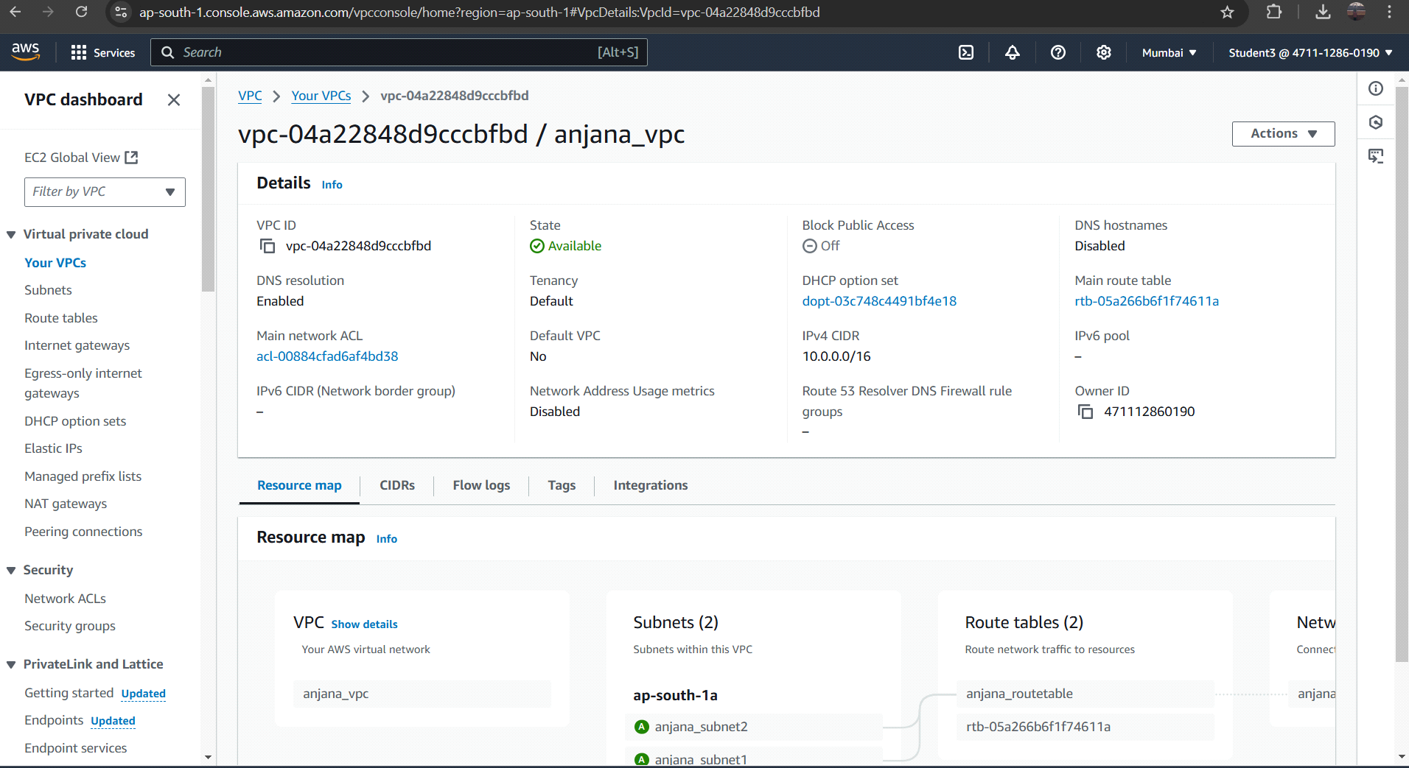

**Subnet:**

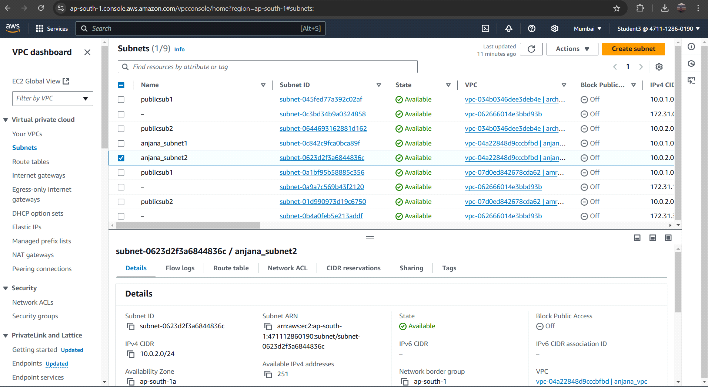

**Subnet1:**

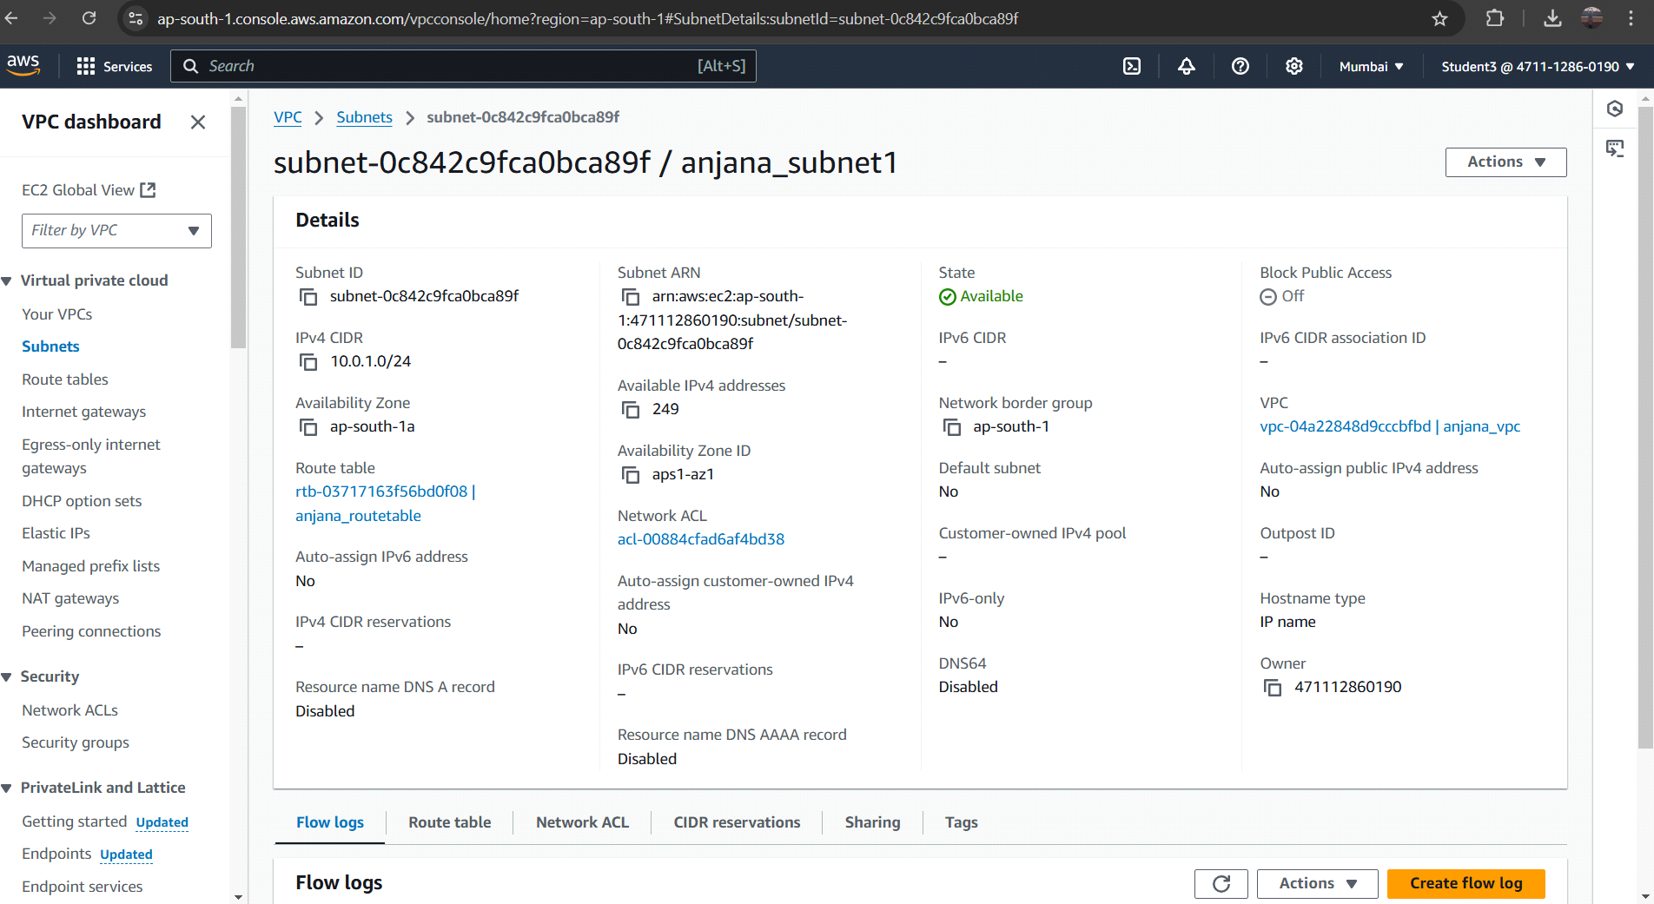

**Subnet2:**

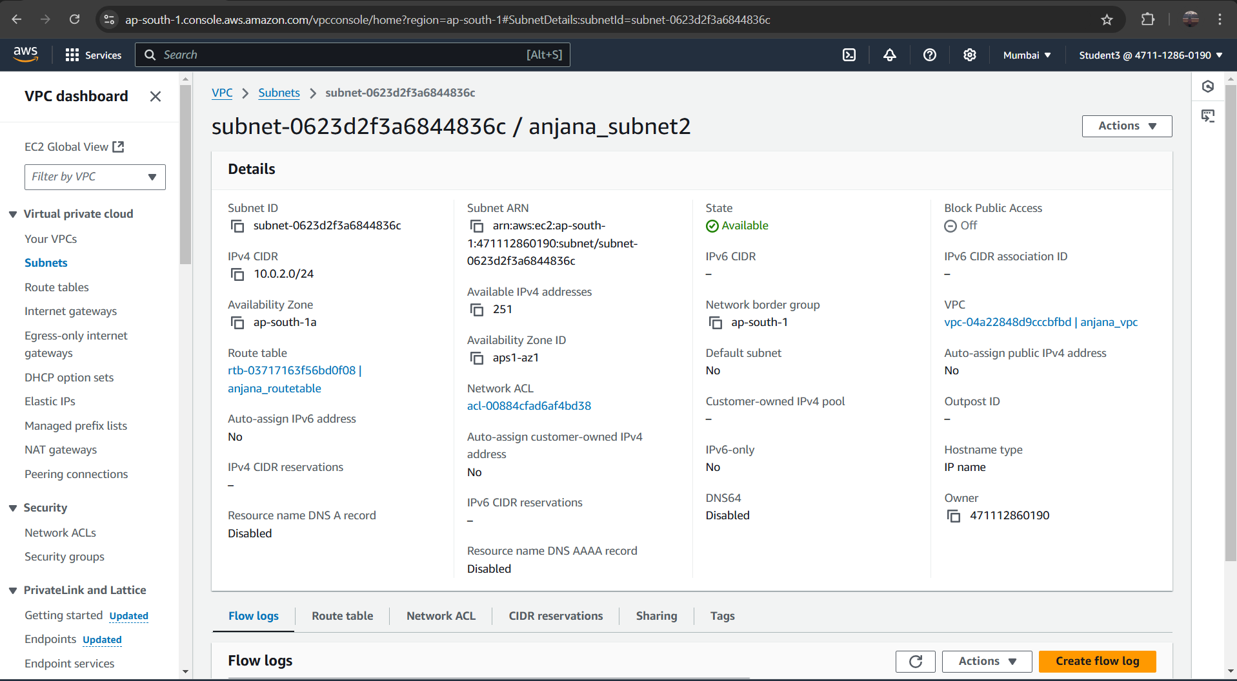

**Router Table:**

**Steps:**

**1. To create Route table, click on create route table.**

**2. In route table setting, give route table name as anjana-routetable and select vpc that is**

**created.**

**3. Then click on create route table.**

**4. After route table is created, go to routes and click on edit route and then click on add**

**route.**

**5. Then in destination, select 0.0.0.0/0 as destination and target as Internet Gateways.**

**6. After selecting internet gateway, it allows to select the igw- and select the internet**

**gateway that is created by you.**

**7. At last, click on save changes.**

**8. Then go to subnet association and click on edit subnet association.**

**9. Select the subnet you have created and click on save changes.**

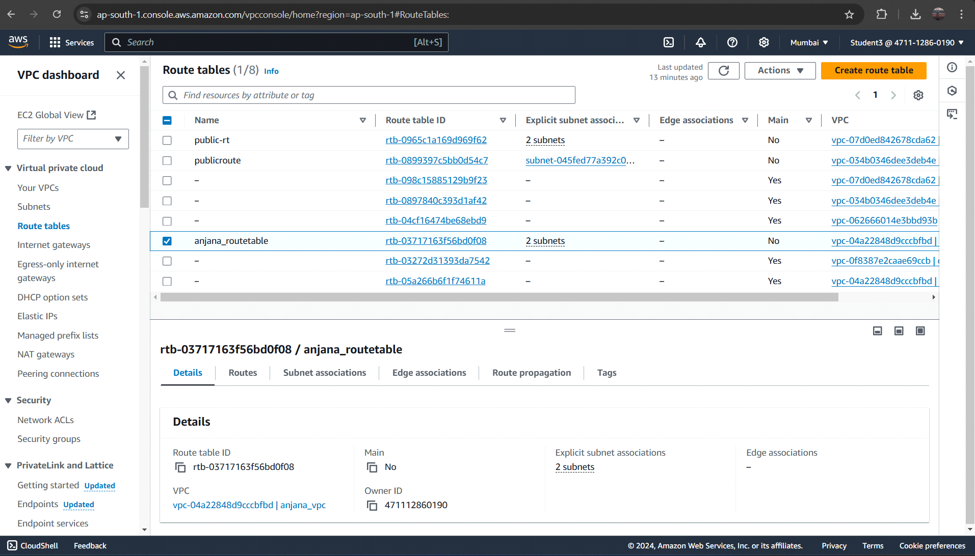

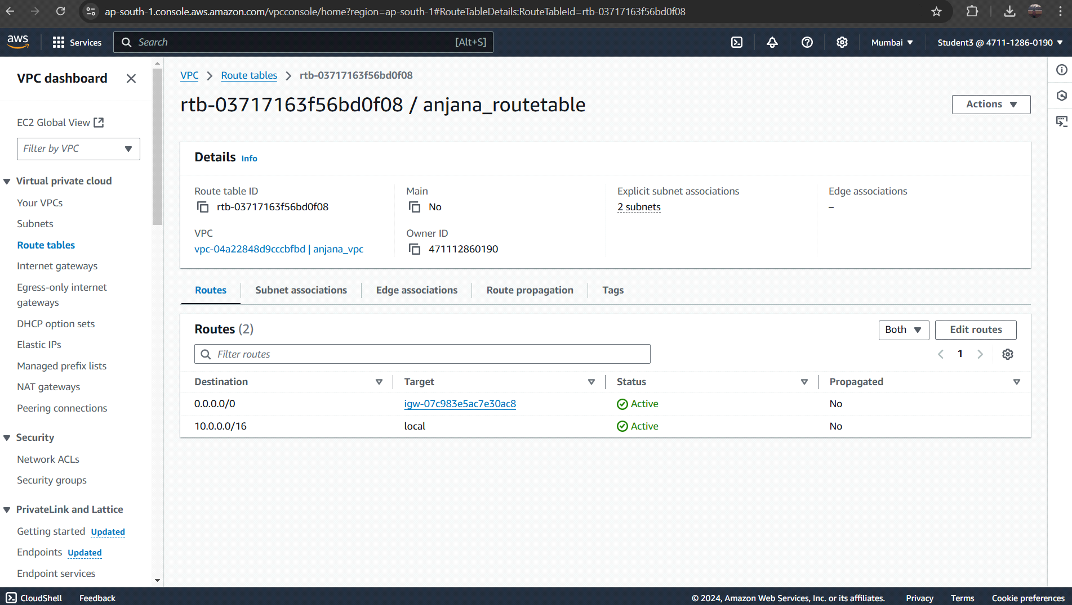

**Internet Gateway:**

**Steps:**

**1. In VPC dashboard, click on Internet Gateway.**

**2. To create Internet gateway, click on create Internet Gateway.**

**3. Then give name as anjana-igw and click on create Internet Gateway.**

**4. Your internet Gateway is created.**

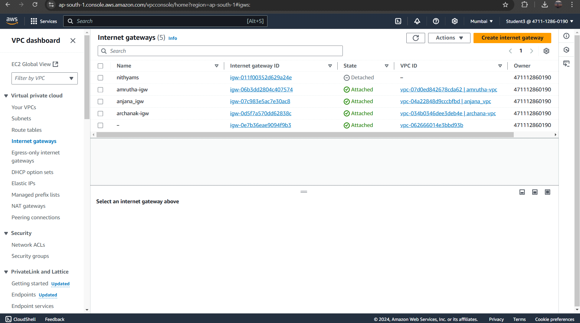

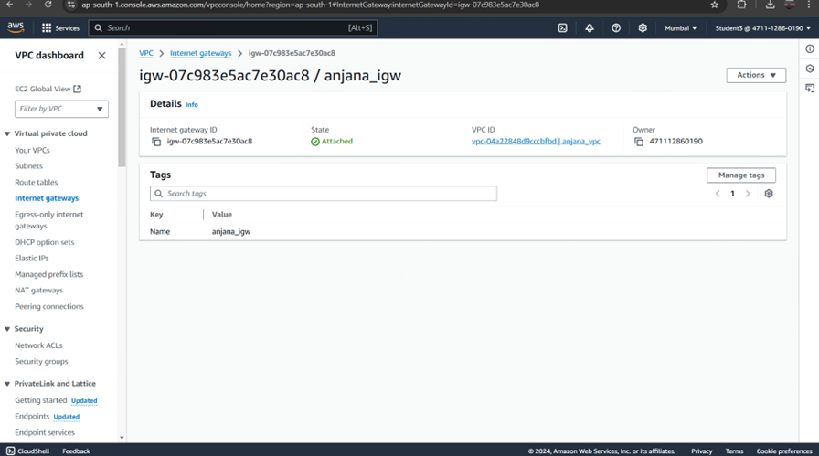

**E2C Instance:**

**Steps:**

**1. Go to EC2 in AWS console and click on instances.**

**2. Click on launch instance and give the name for the instances as chaithali-server.**

**3. After giving name to instances, select application and OS Images as Amazon Linux**

**and instances type as t2.micro .**

**4. In keypair, click on create keypair and give keypair name as chaithali-keypair and**

**click on create keypair. The keypair is created.**

**5. Then in network setting, click edit. Select vpc and subnet and also assign public IP as**

**enable.**

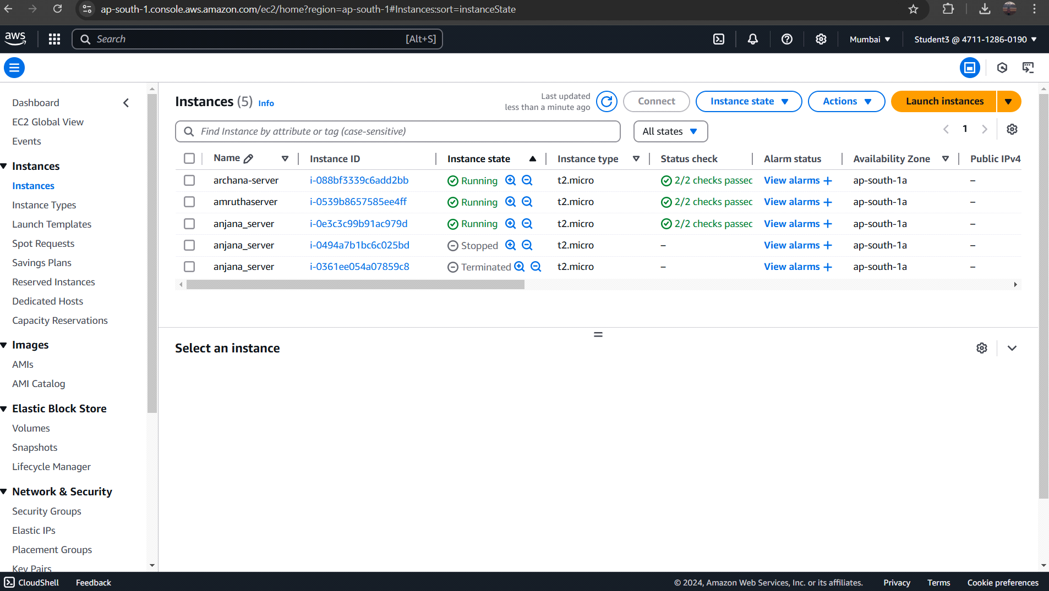

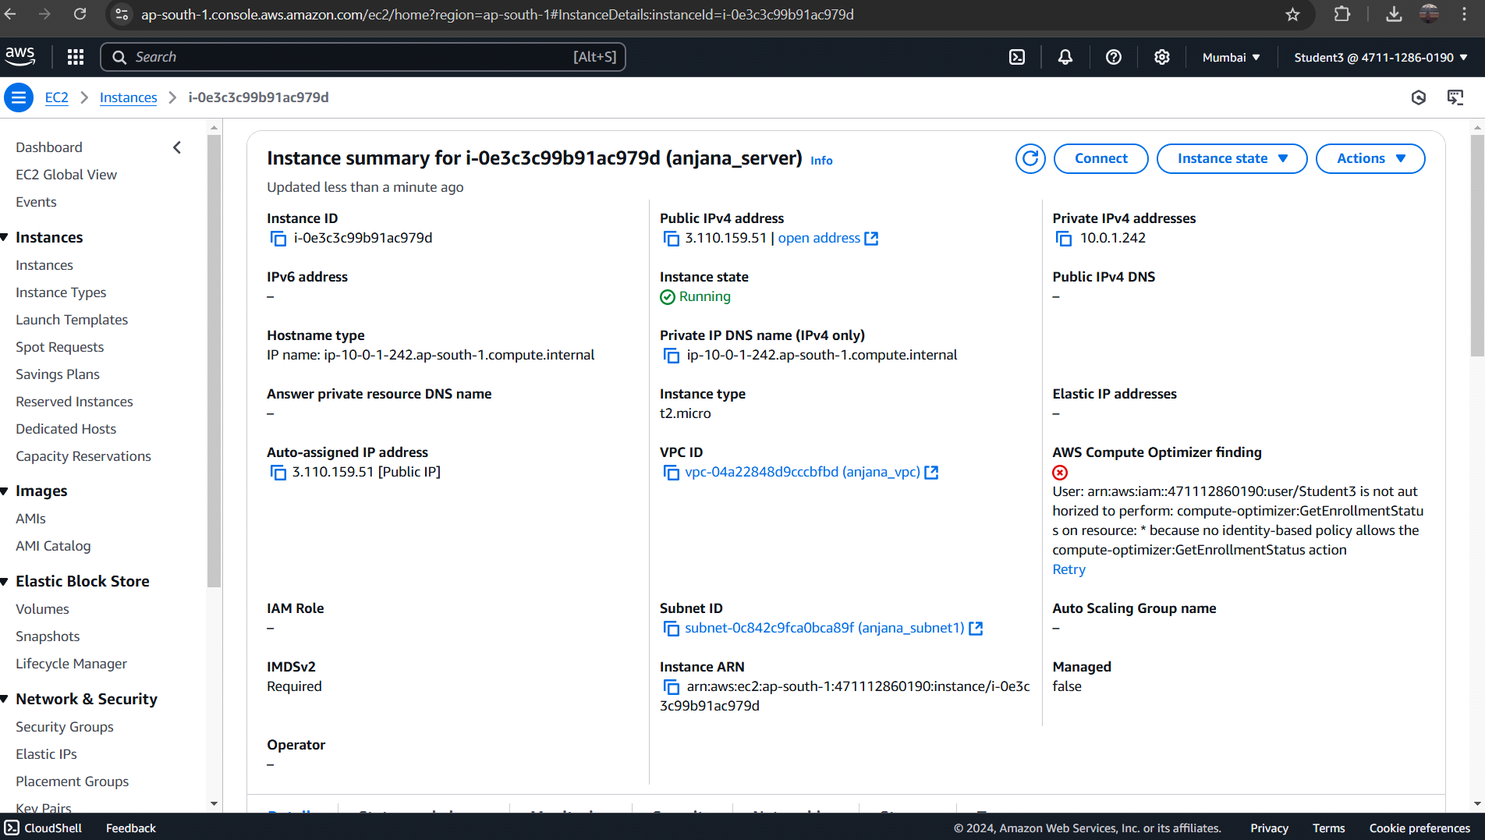

**Command prompt**

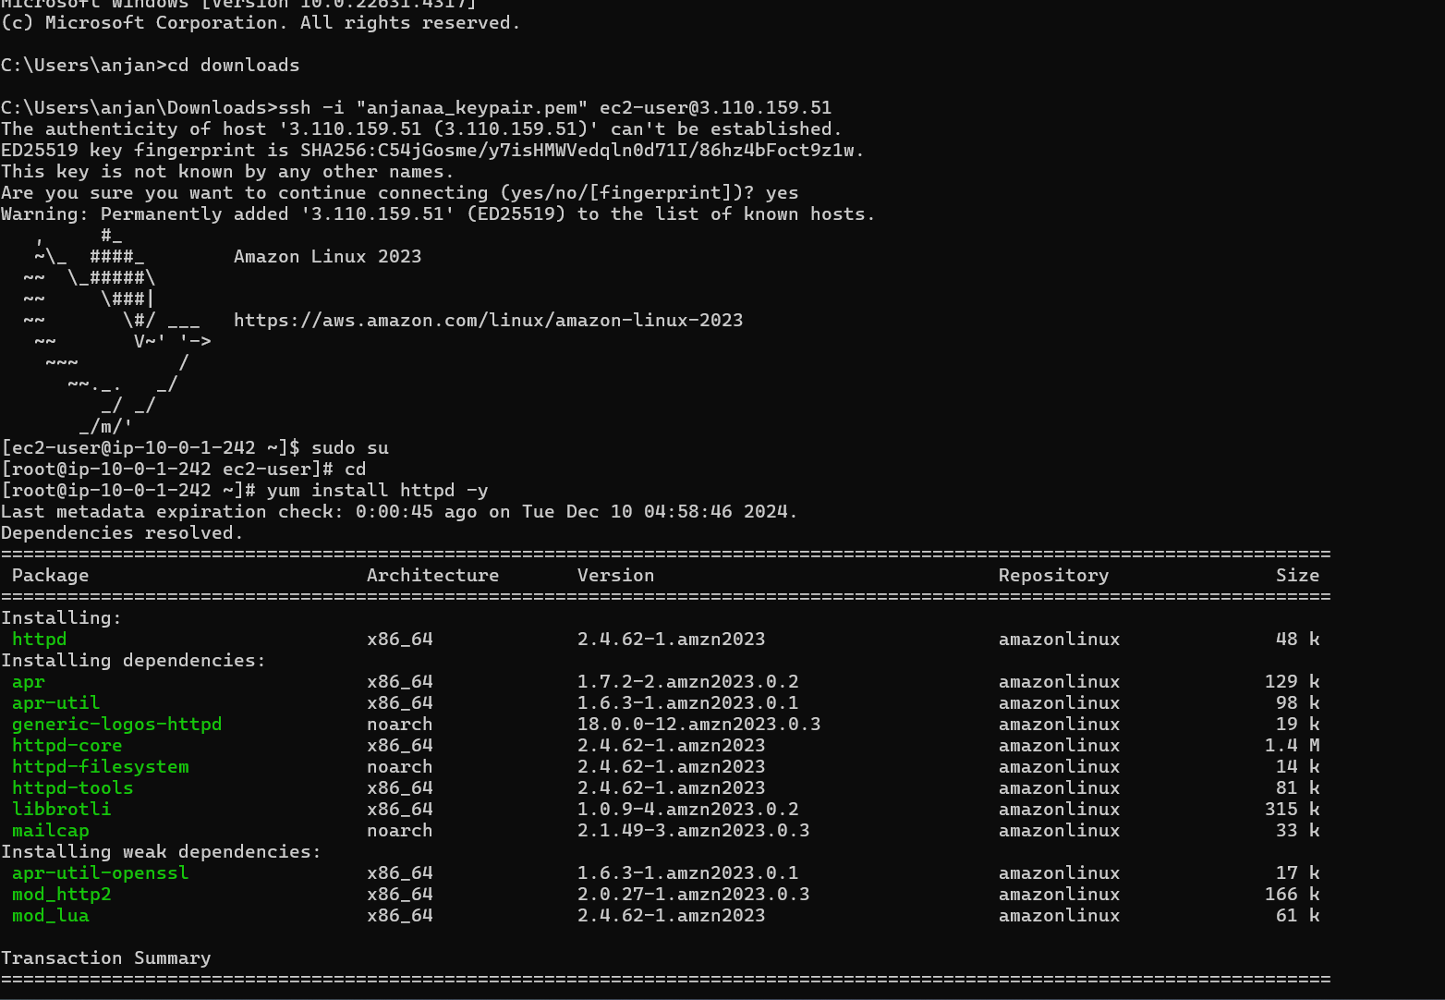

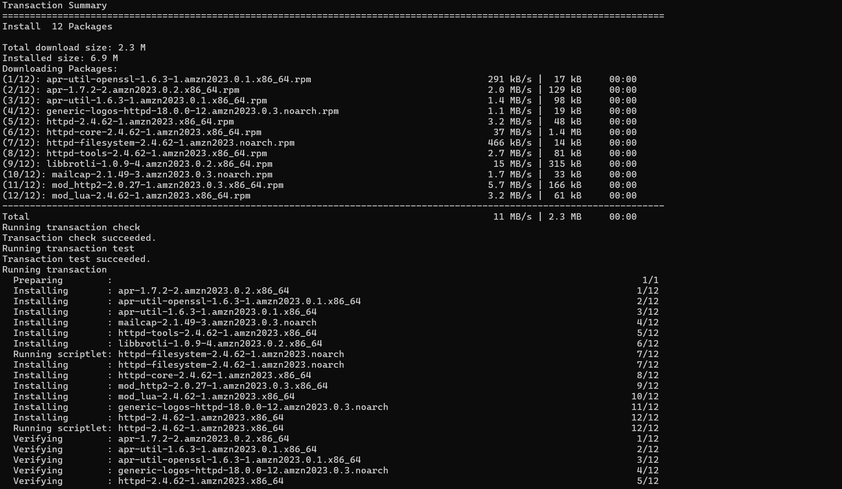

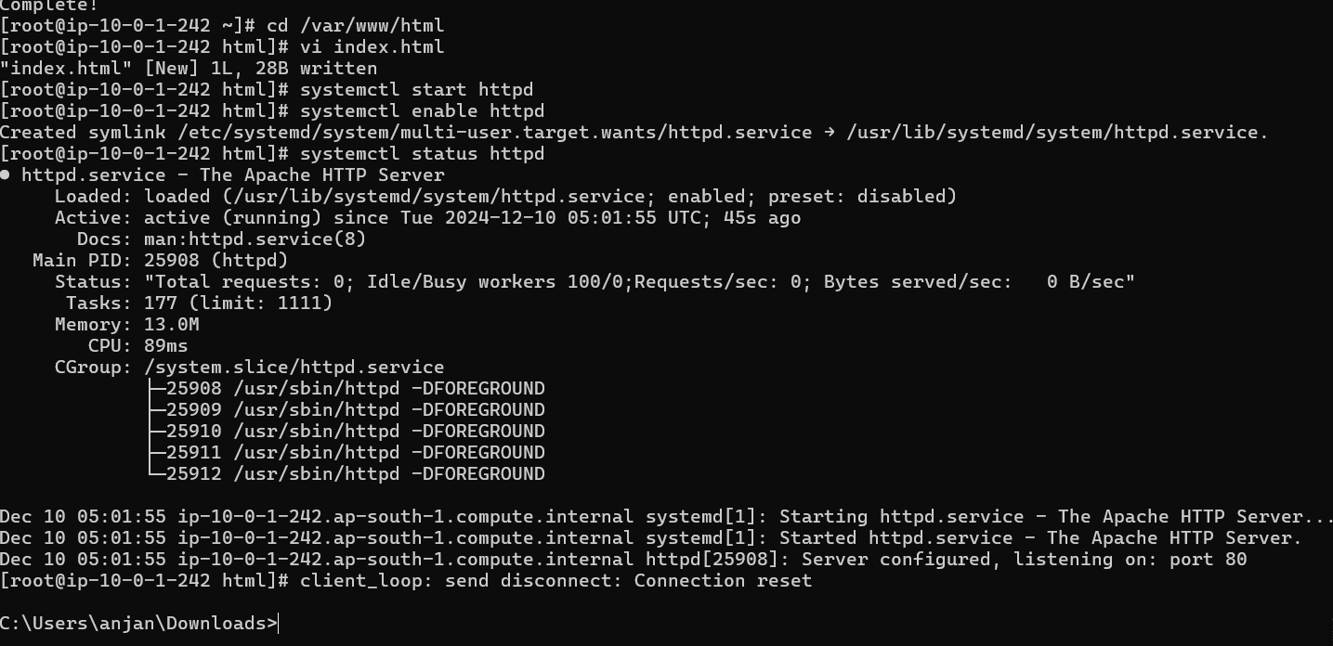

**output**



**Project 2: How to create new instance using AMI**

**Creating Image:**

**Steps:**

**1. To create image using AMI, go to EC2 and click on instances.**

**2. Select the instance that is created before and click on action.**

**3. In action, select image and template. In image and template, select create images.**

**4. Give name as anjana-server-backup and description to the instances.**

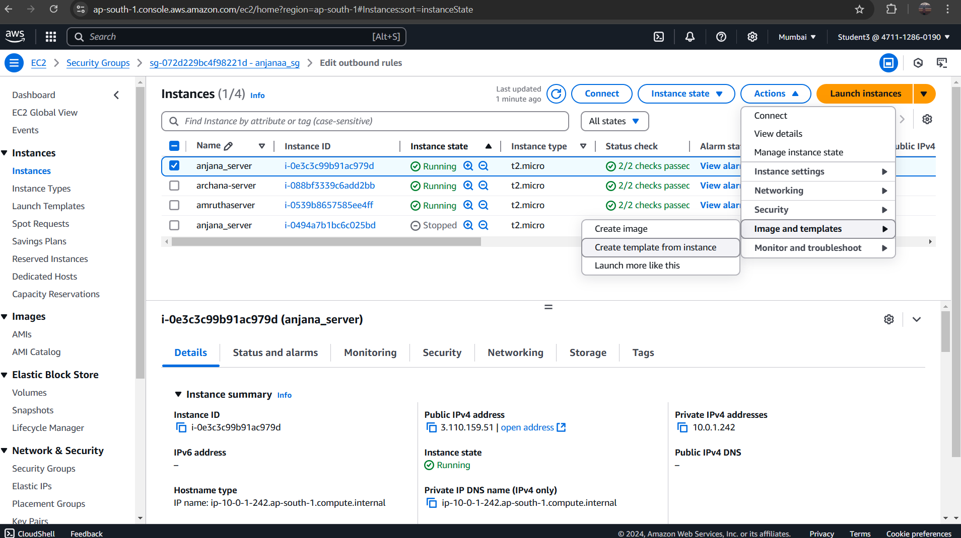

**Backup:**

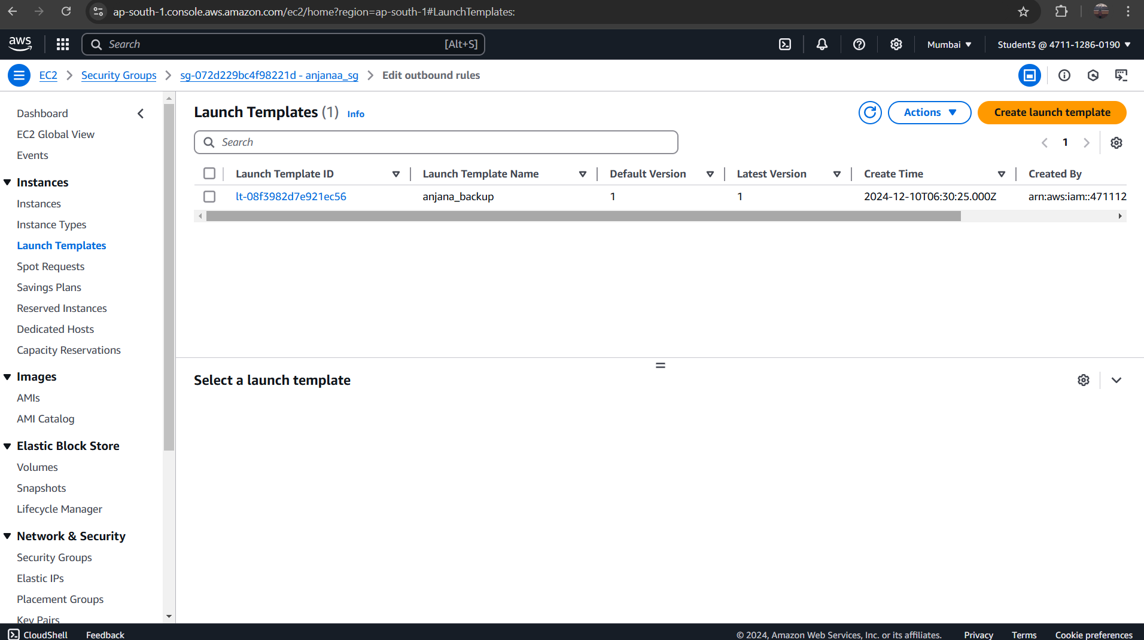

**After Launching the Backup Server:**

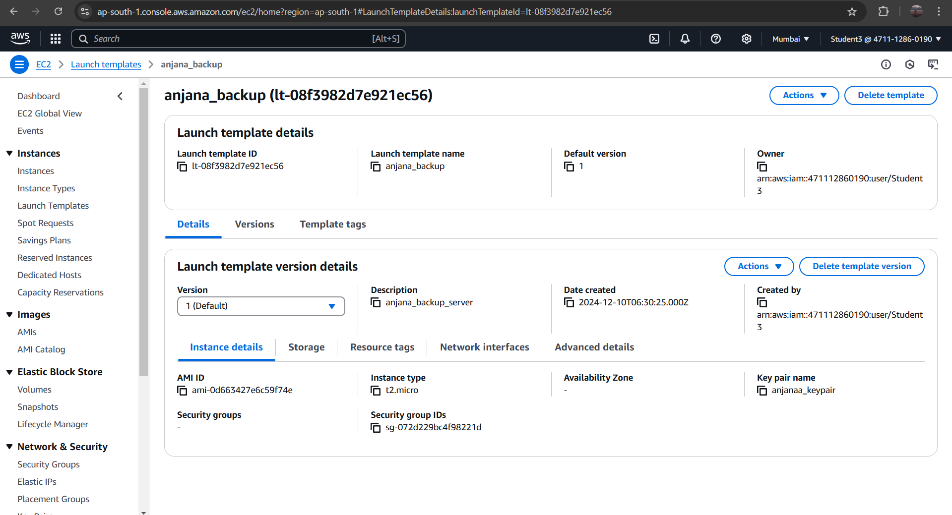

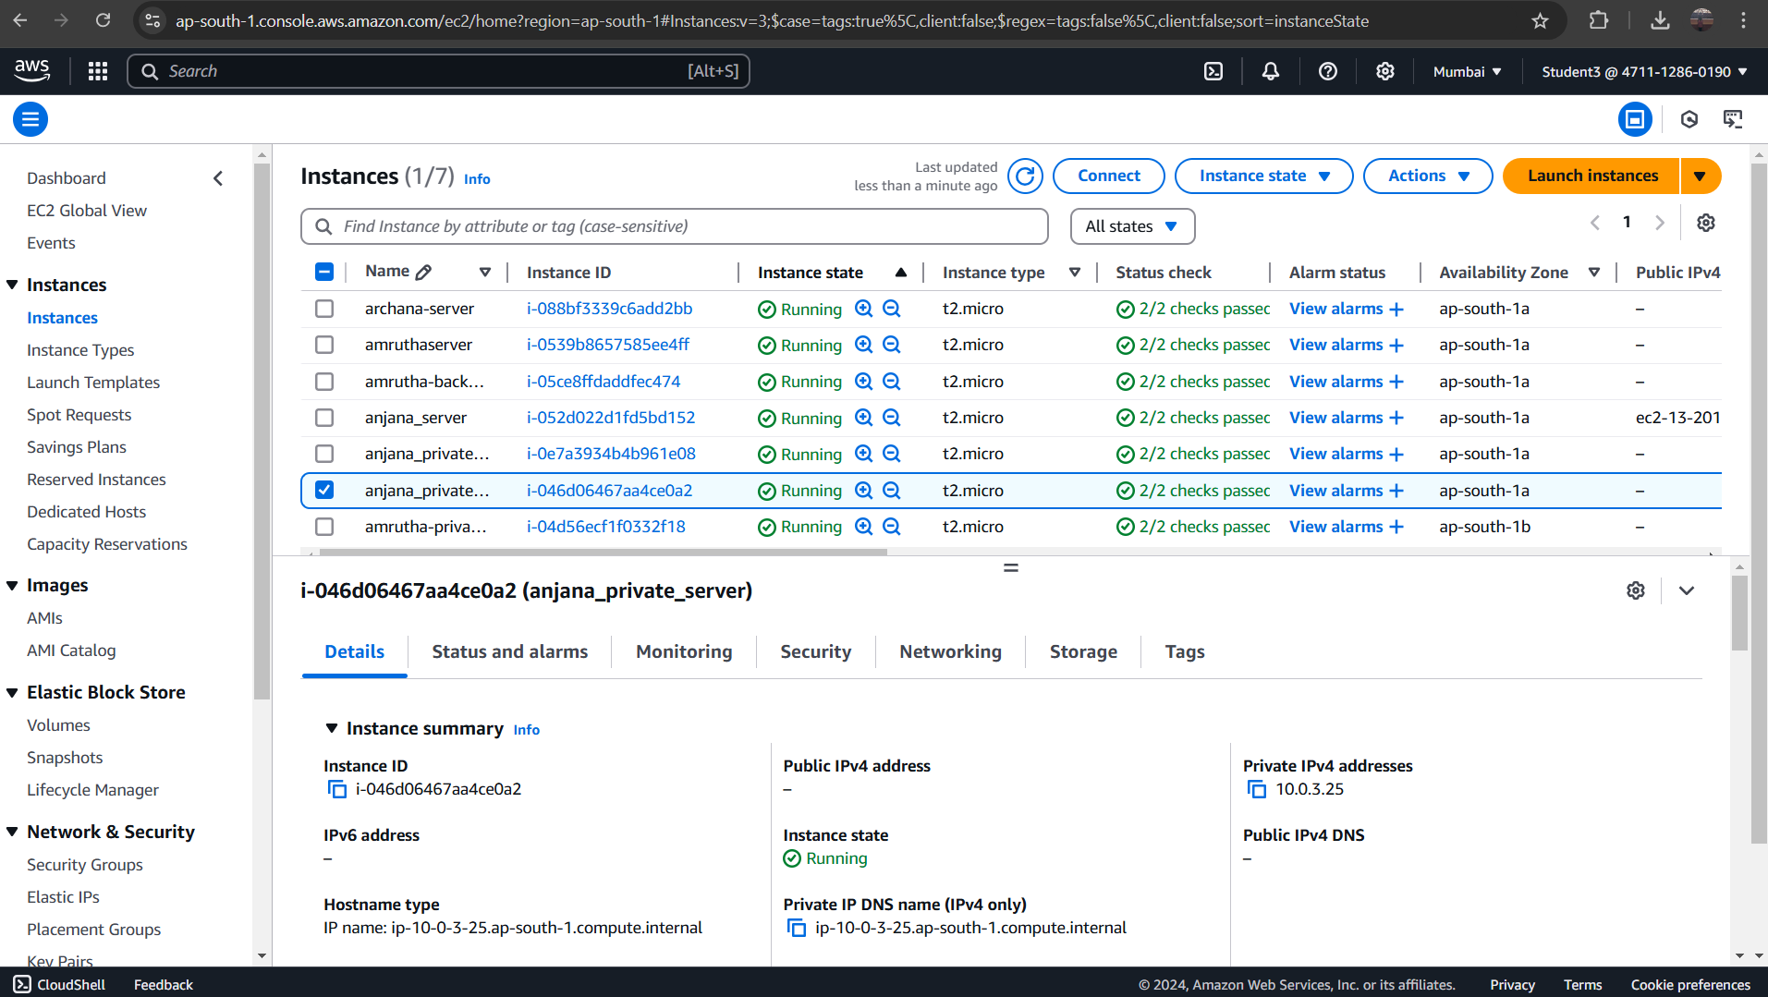

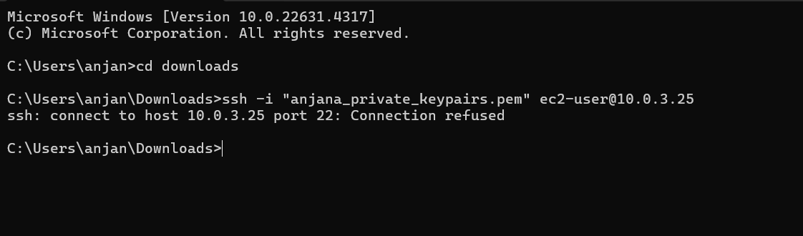

**Project 3: How to Connect Private Server to Internet using NAT**

**Gateway (Jump Server/Bastion Host)**

**Virtual Private Cloud:**

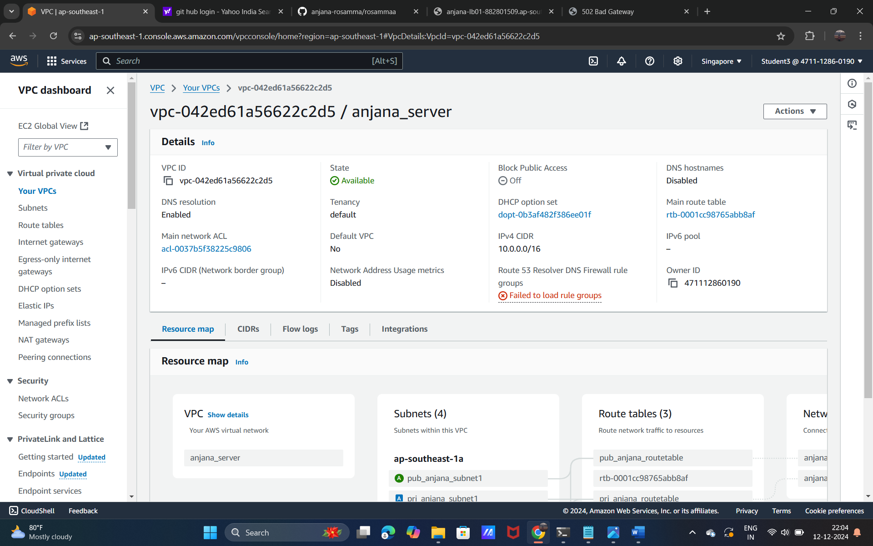

**Creating internet gatway**

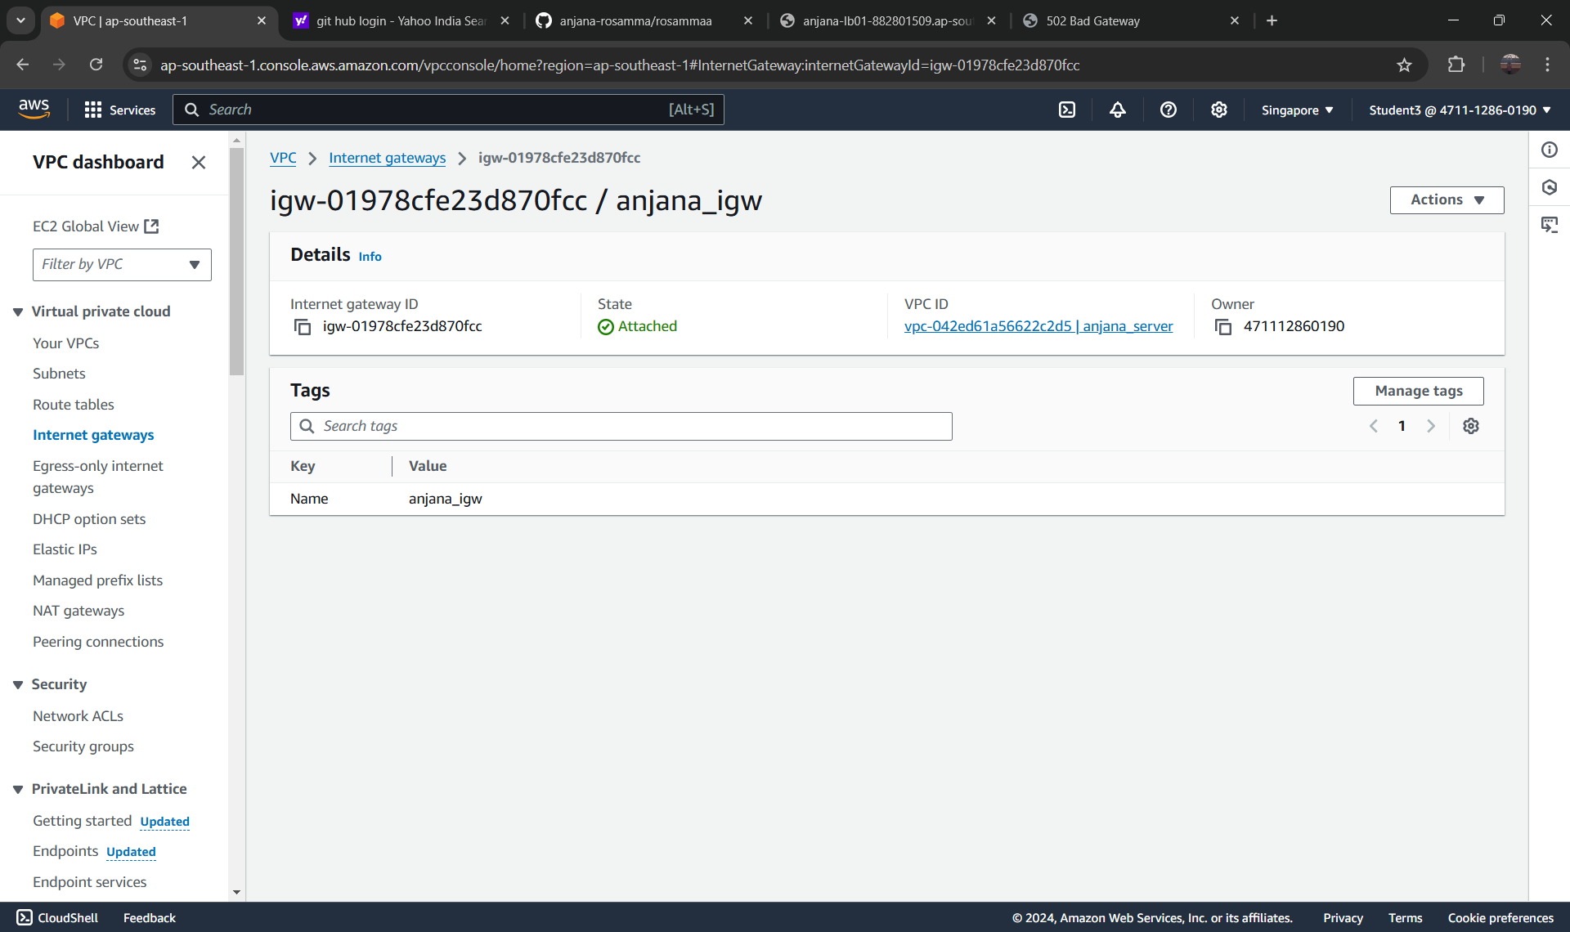

**Public-subnet**

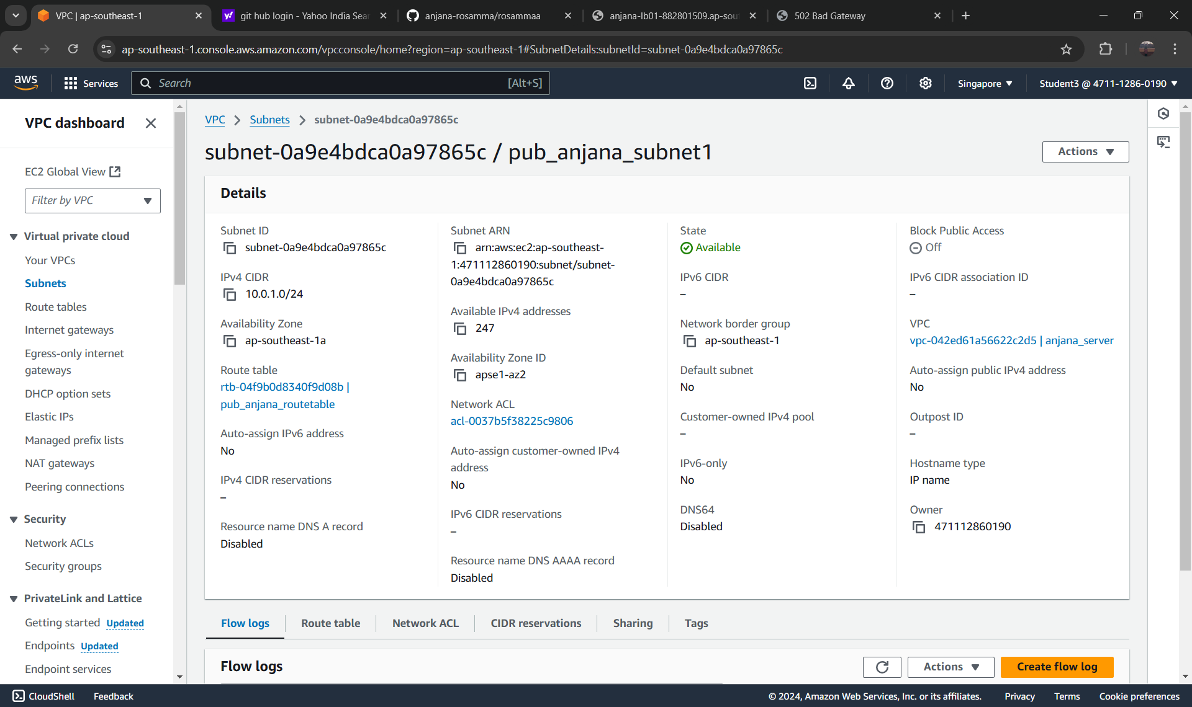

**Private-subnet**

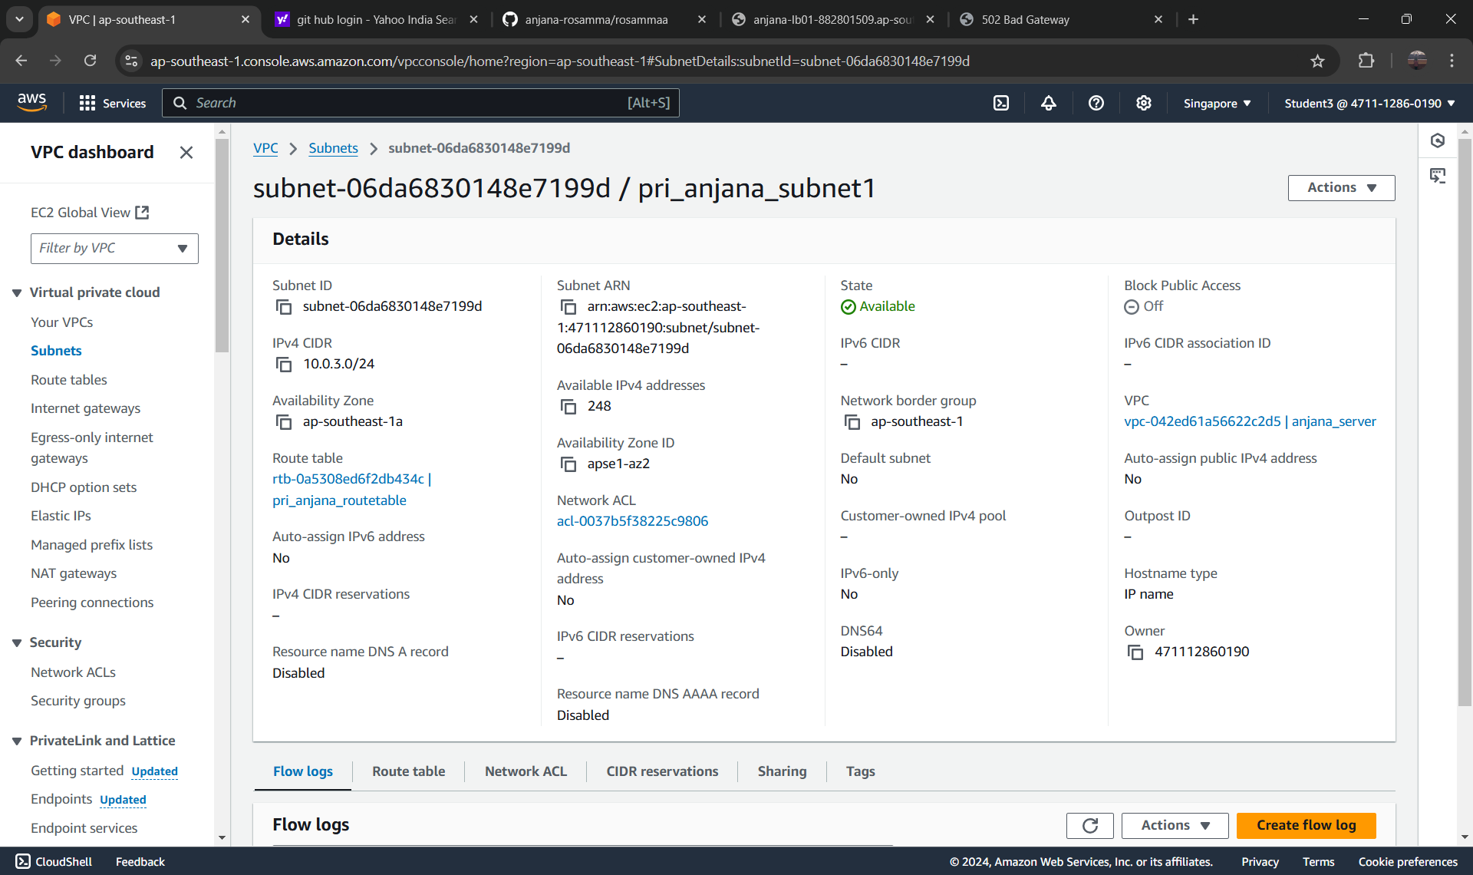

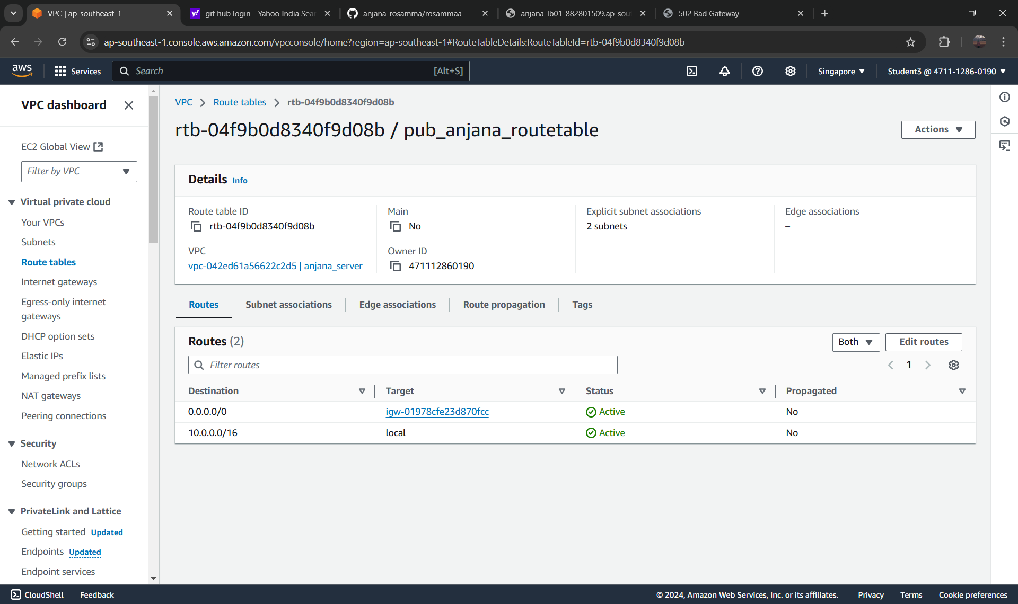

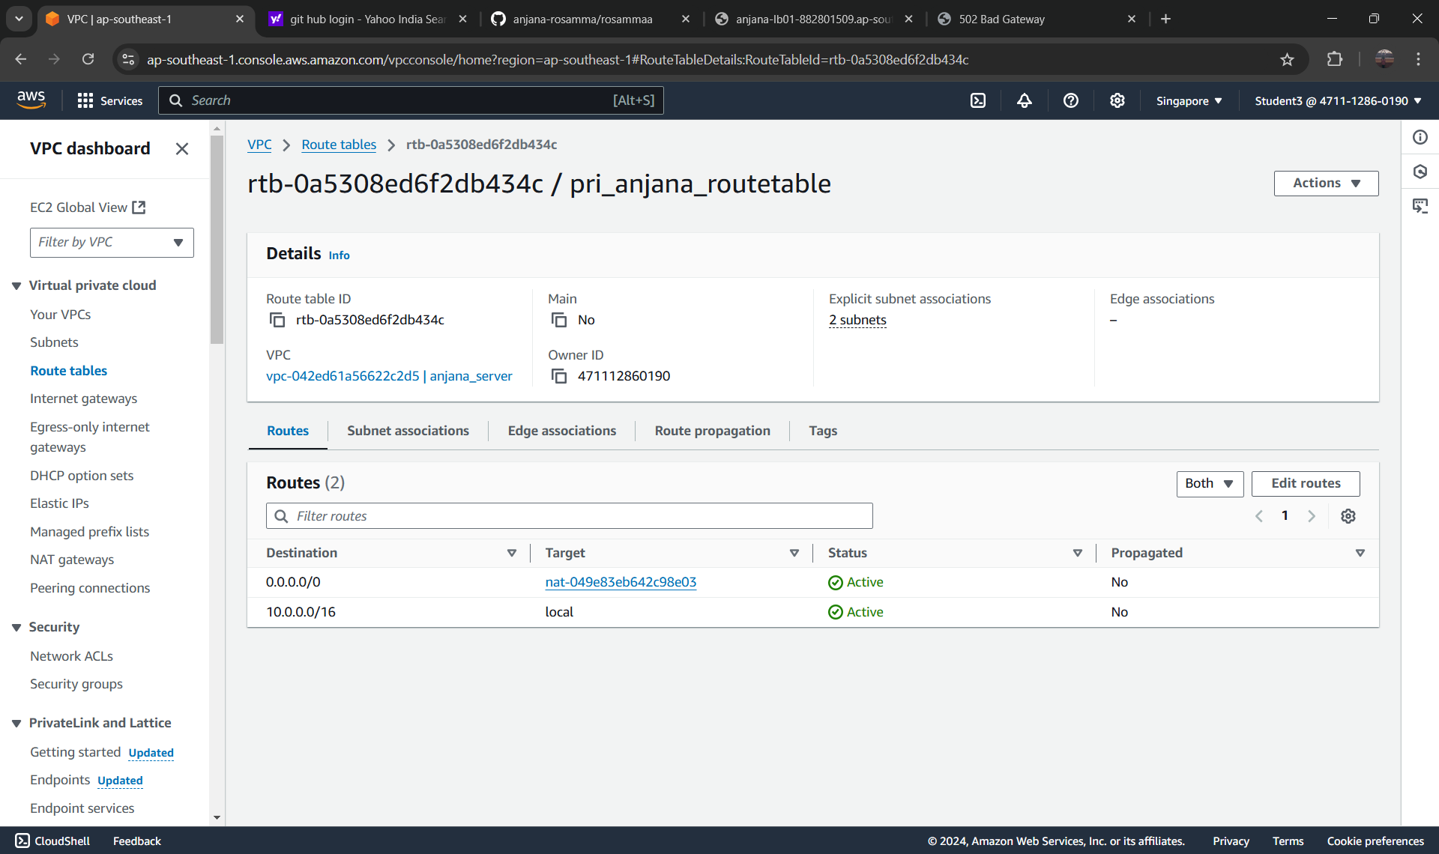

**NAT**

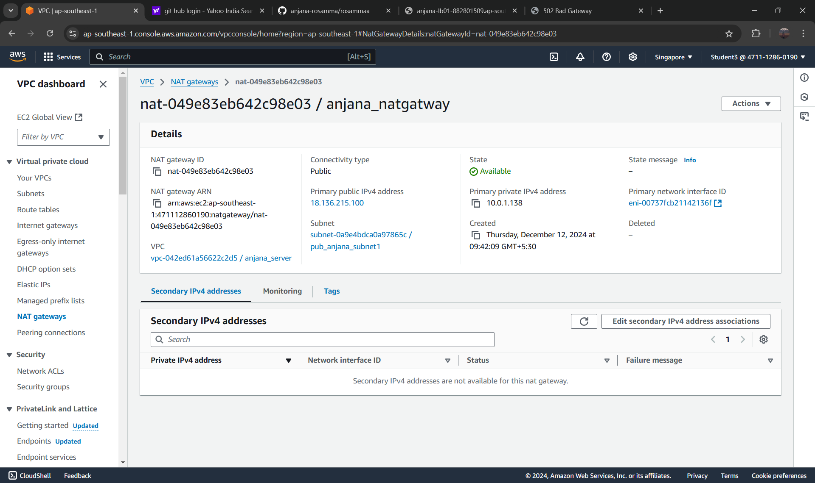

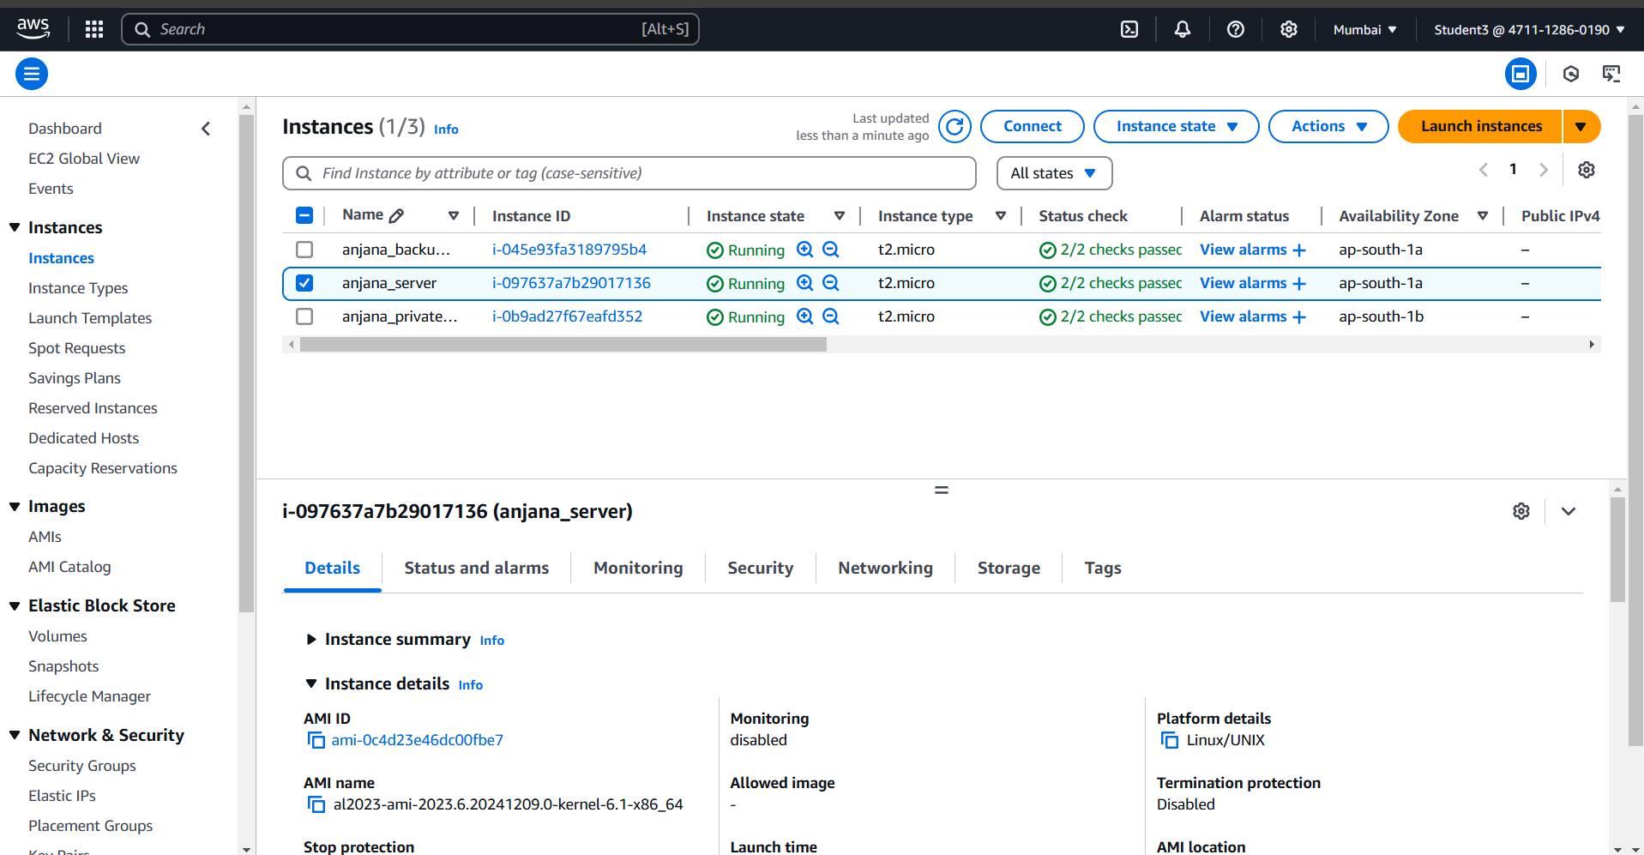

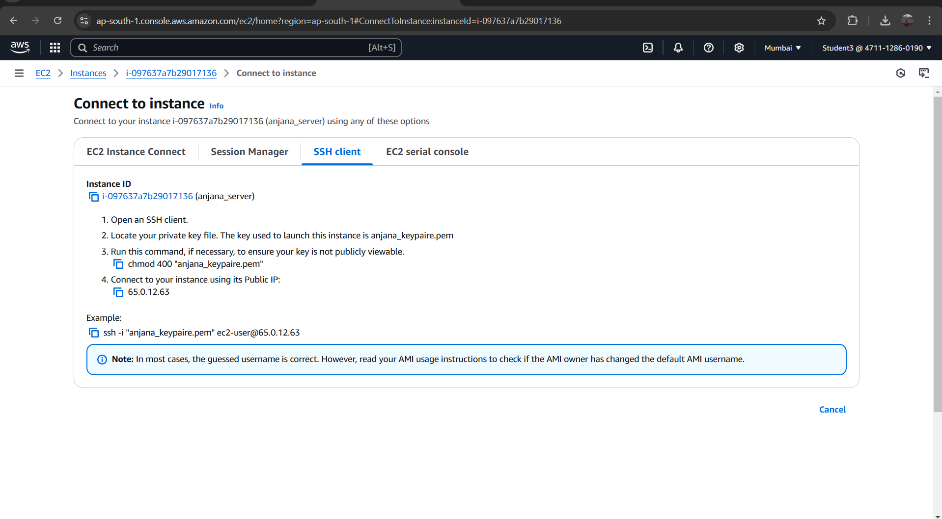

**Pinging to google**

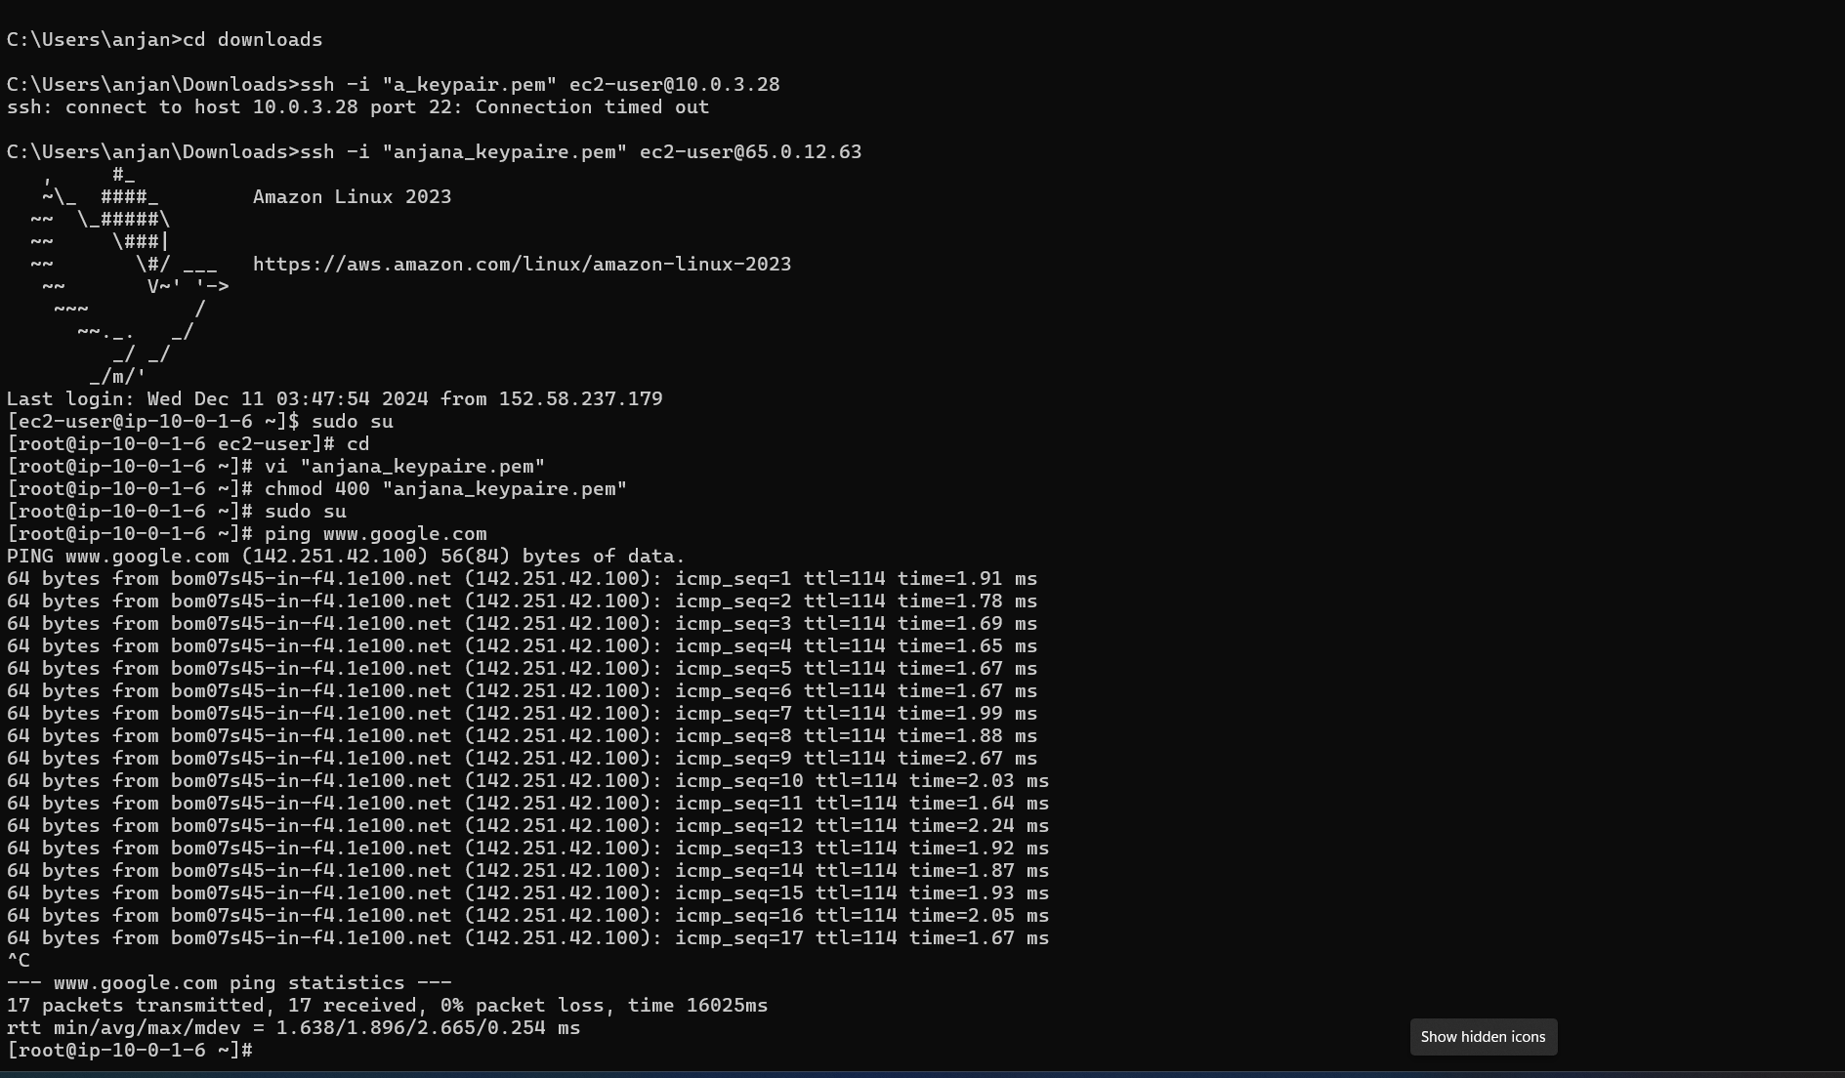

**Project 4: Hosting a static website using S3 Bucket**

**S3 bucket**

**Steps:**

**1. Go to search bar and type s3. Click on s3.**

**2. In S3 dashboard, go to general purpose buckets and click on create**

**bucket button.**

**3. In general configuration, select bucket type as general purpose and give**

**name as anusha04.**

**4. Click on create bucket button. Your bucket is created.**

**Uploading a file:**

**Steps: 1.**

**Click on created bucket.**

**2. Bucket window gets opened and click on upload button.**

**3. In upload window, select files and folders and click on add files and select**

**the file you want to add.**

**4. Then click on upload. Your file is uploaded**

**Static website hosting:**

**Steps:**

**1. Select the properties, go to static website hosting and click on edit.**

**2. Give index document name as file name that is dailyping.html and**

**click on save changes button.**

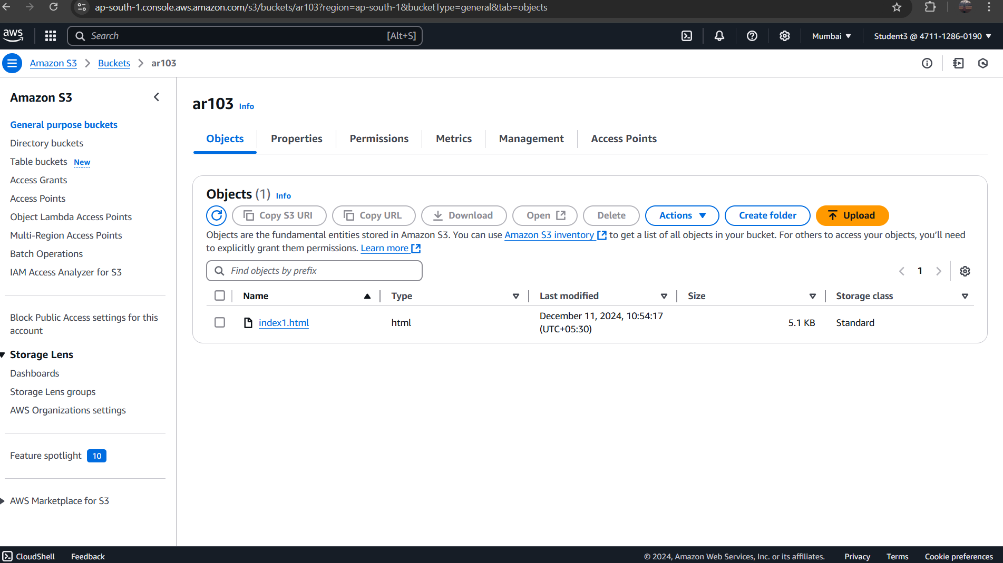

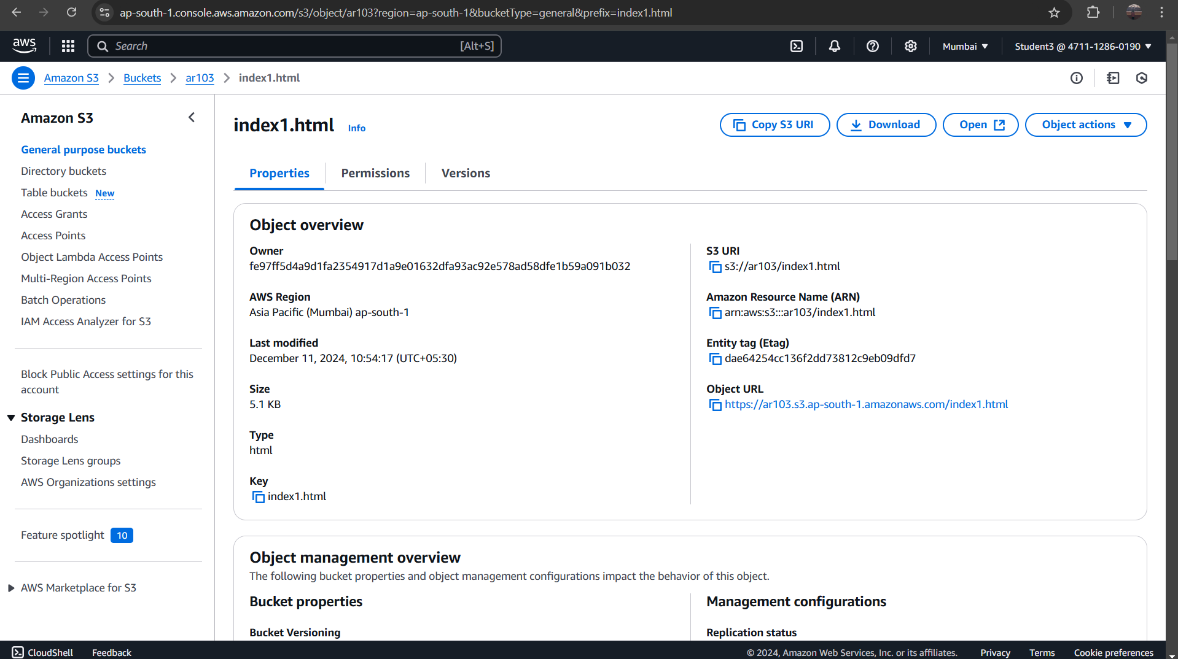

**Setting permission for website access and add bucket policy:**

**Steps:**

**1. Go to google browser and type bucket policy for static website.**

**2. You will get setting permission for website access and click on it.**

**3. You will get add a bucket policy and copy the code from the editor.**

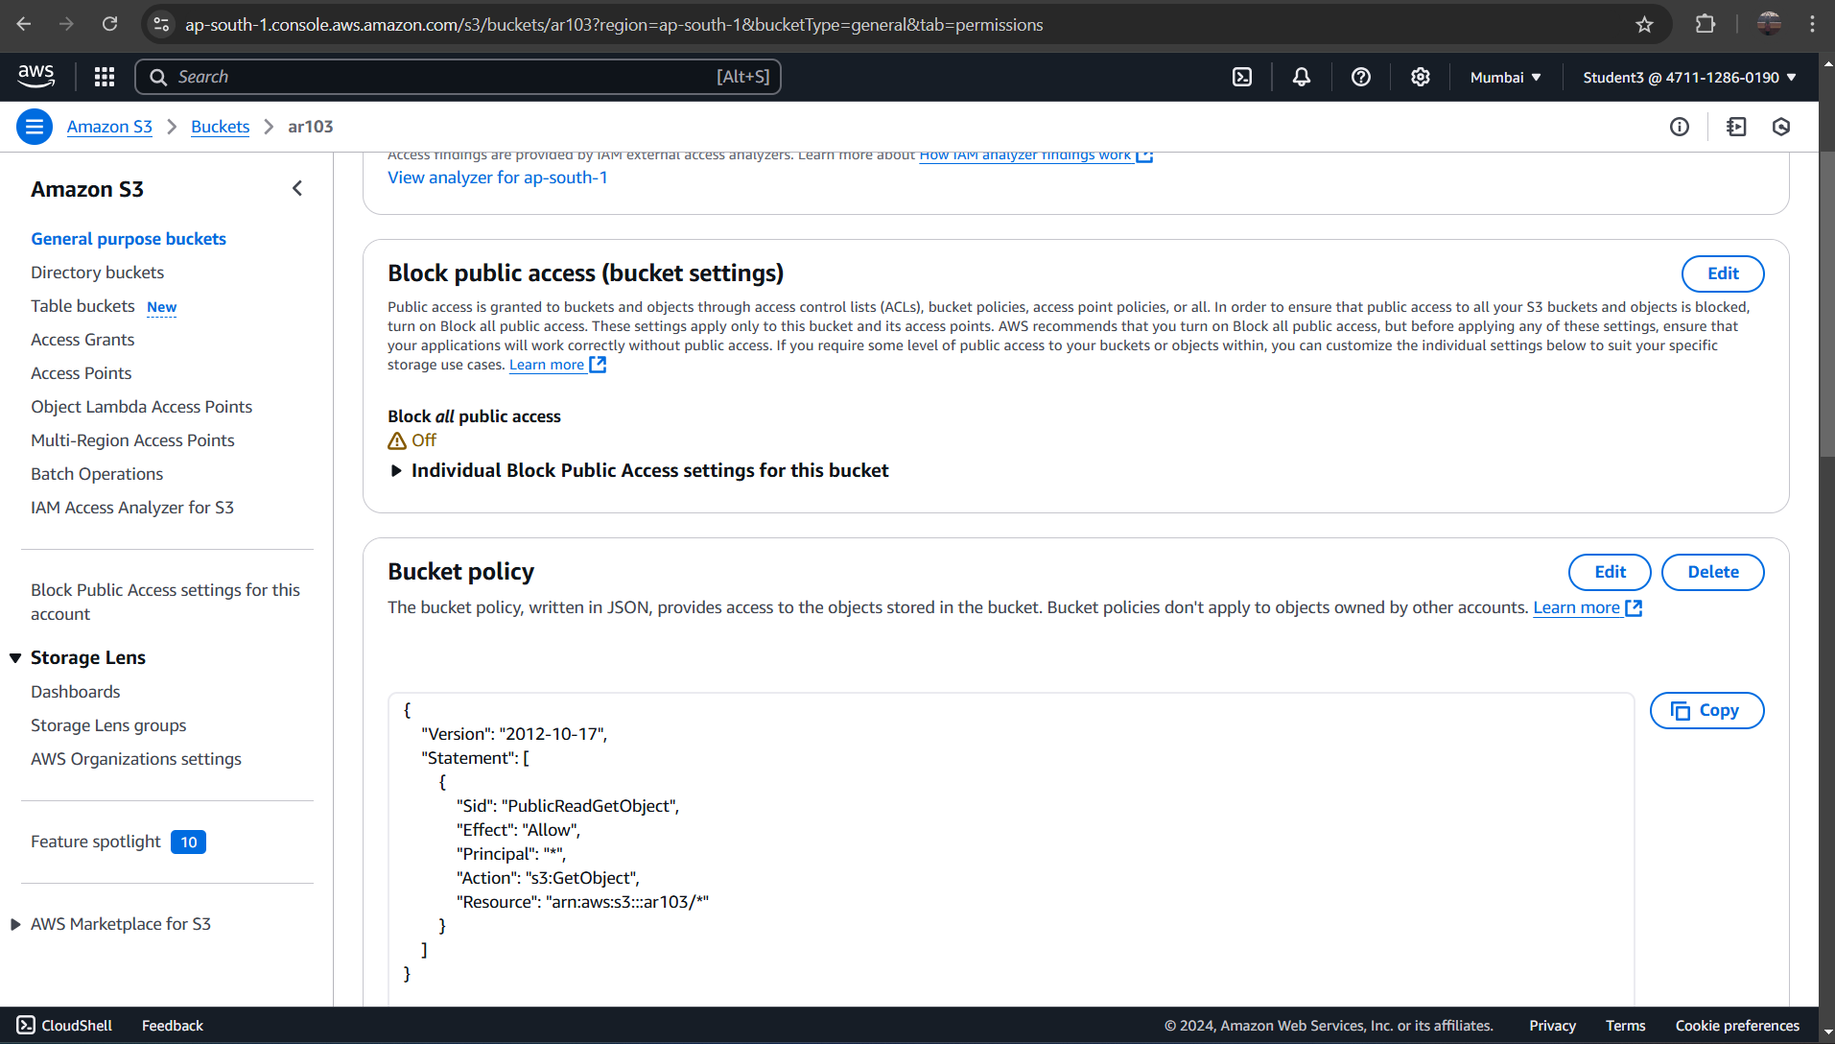

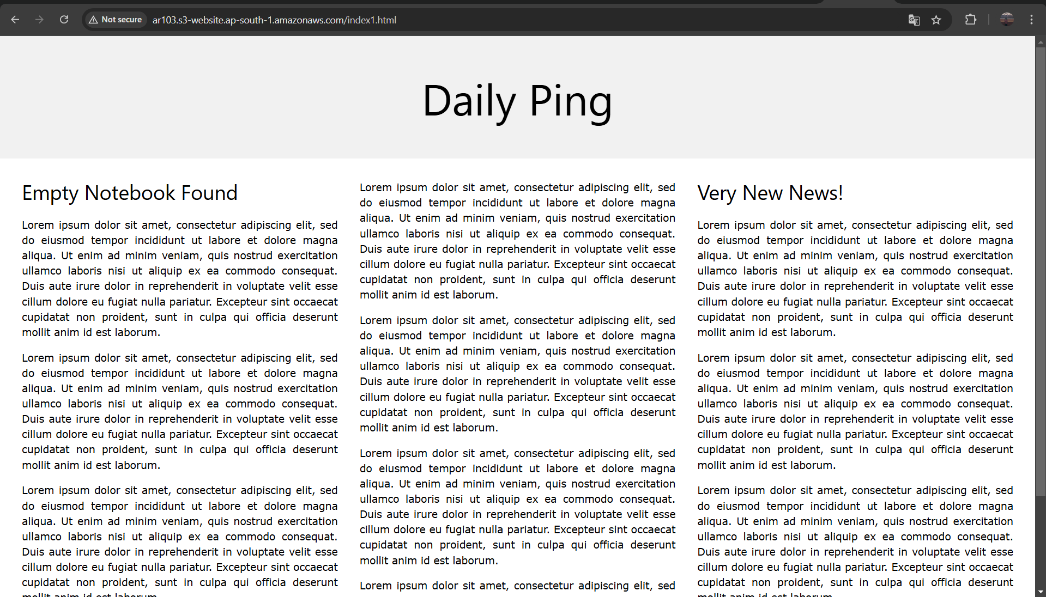

**Project:5**

**Lauching the websit using load balancer DNS name**

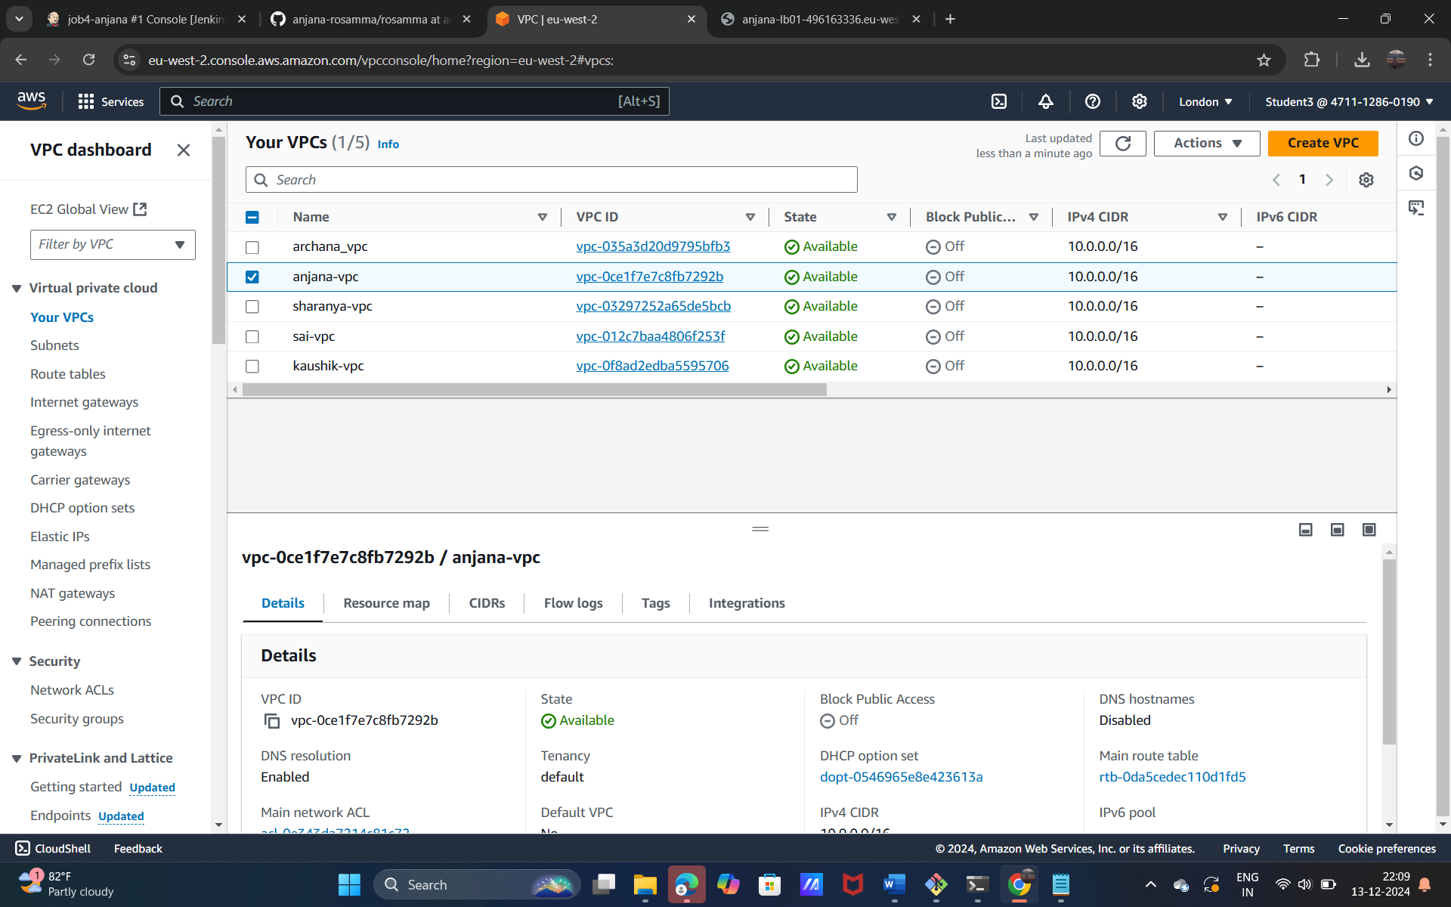

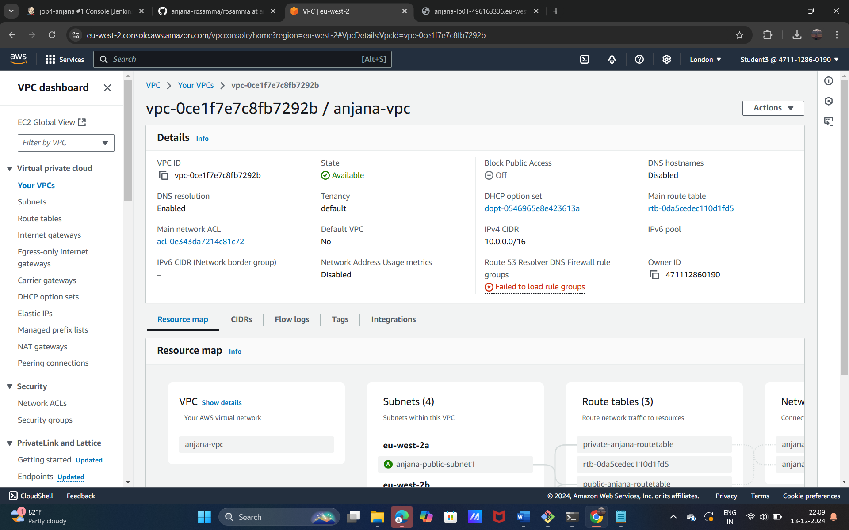

**Internet gatways**

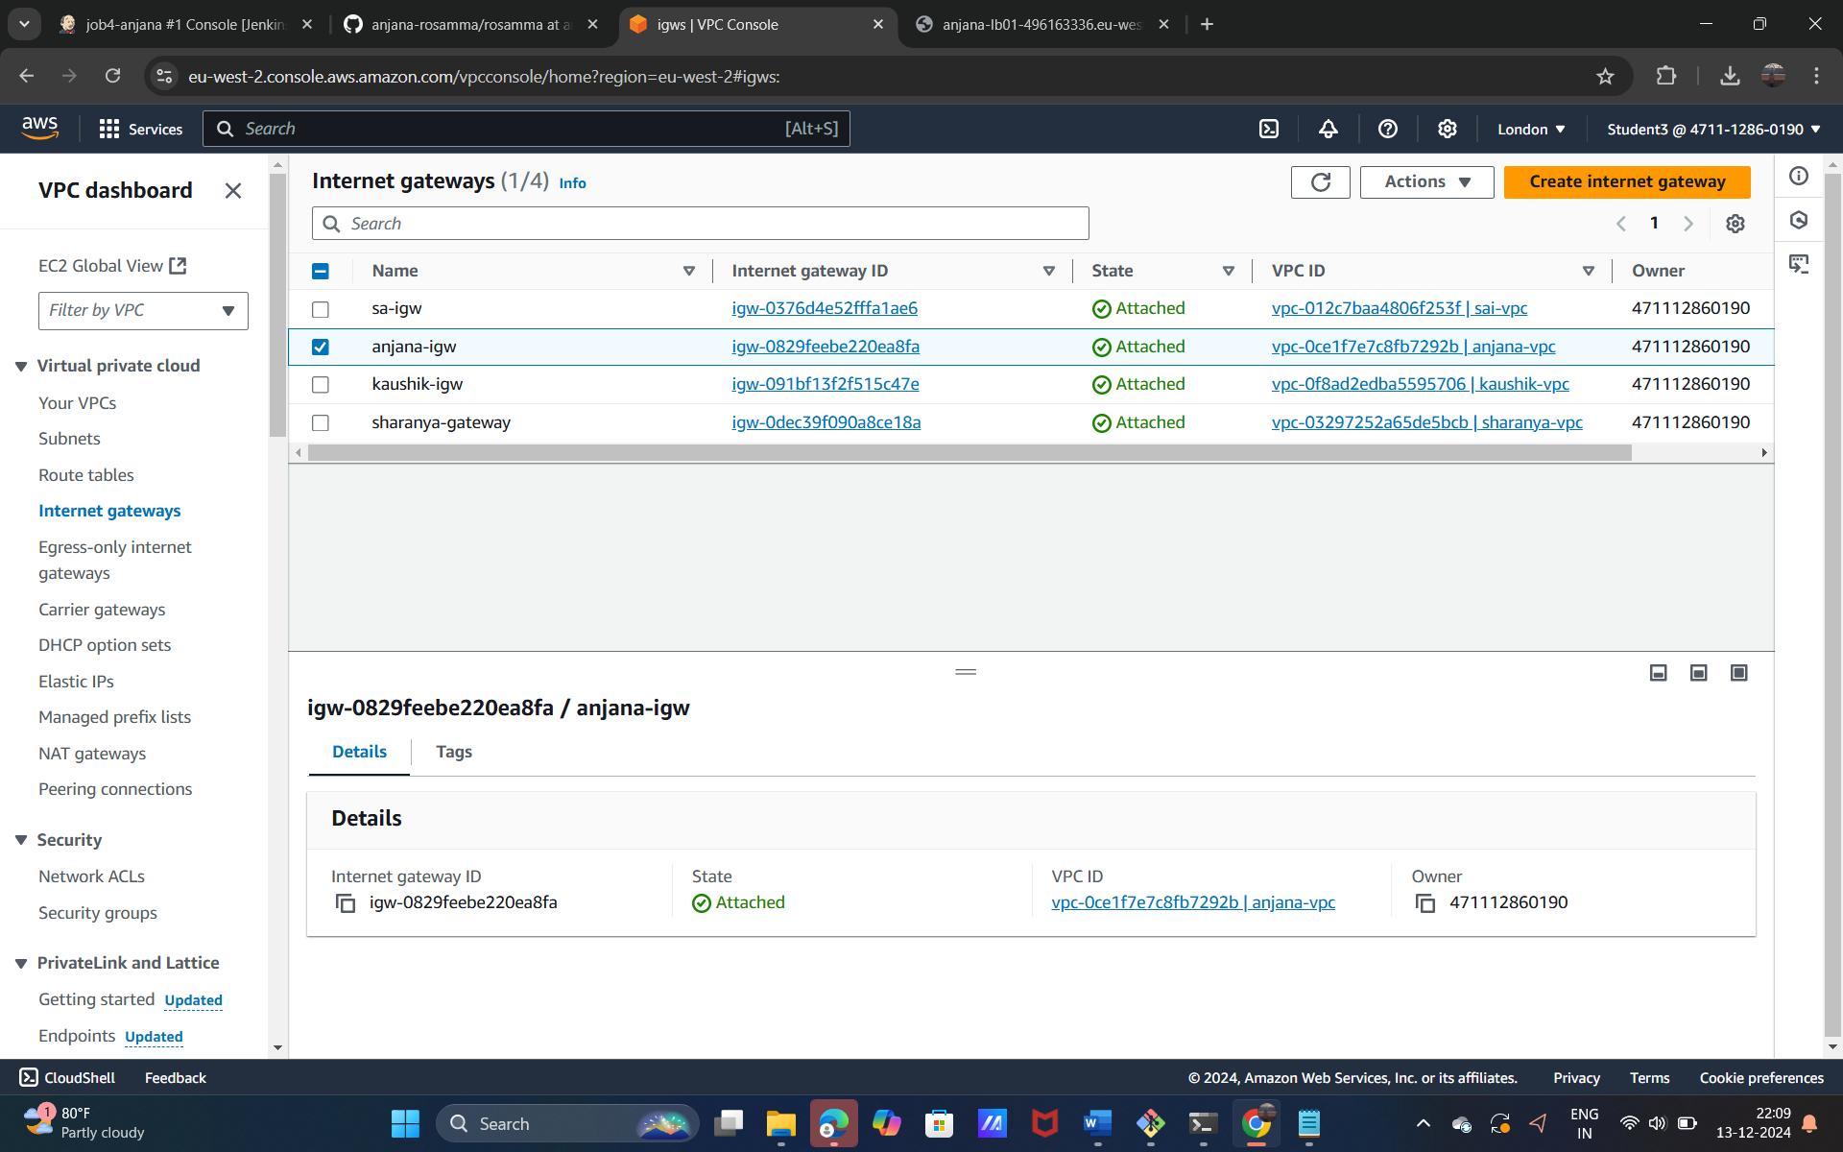

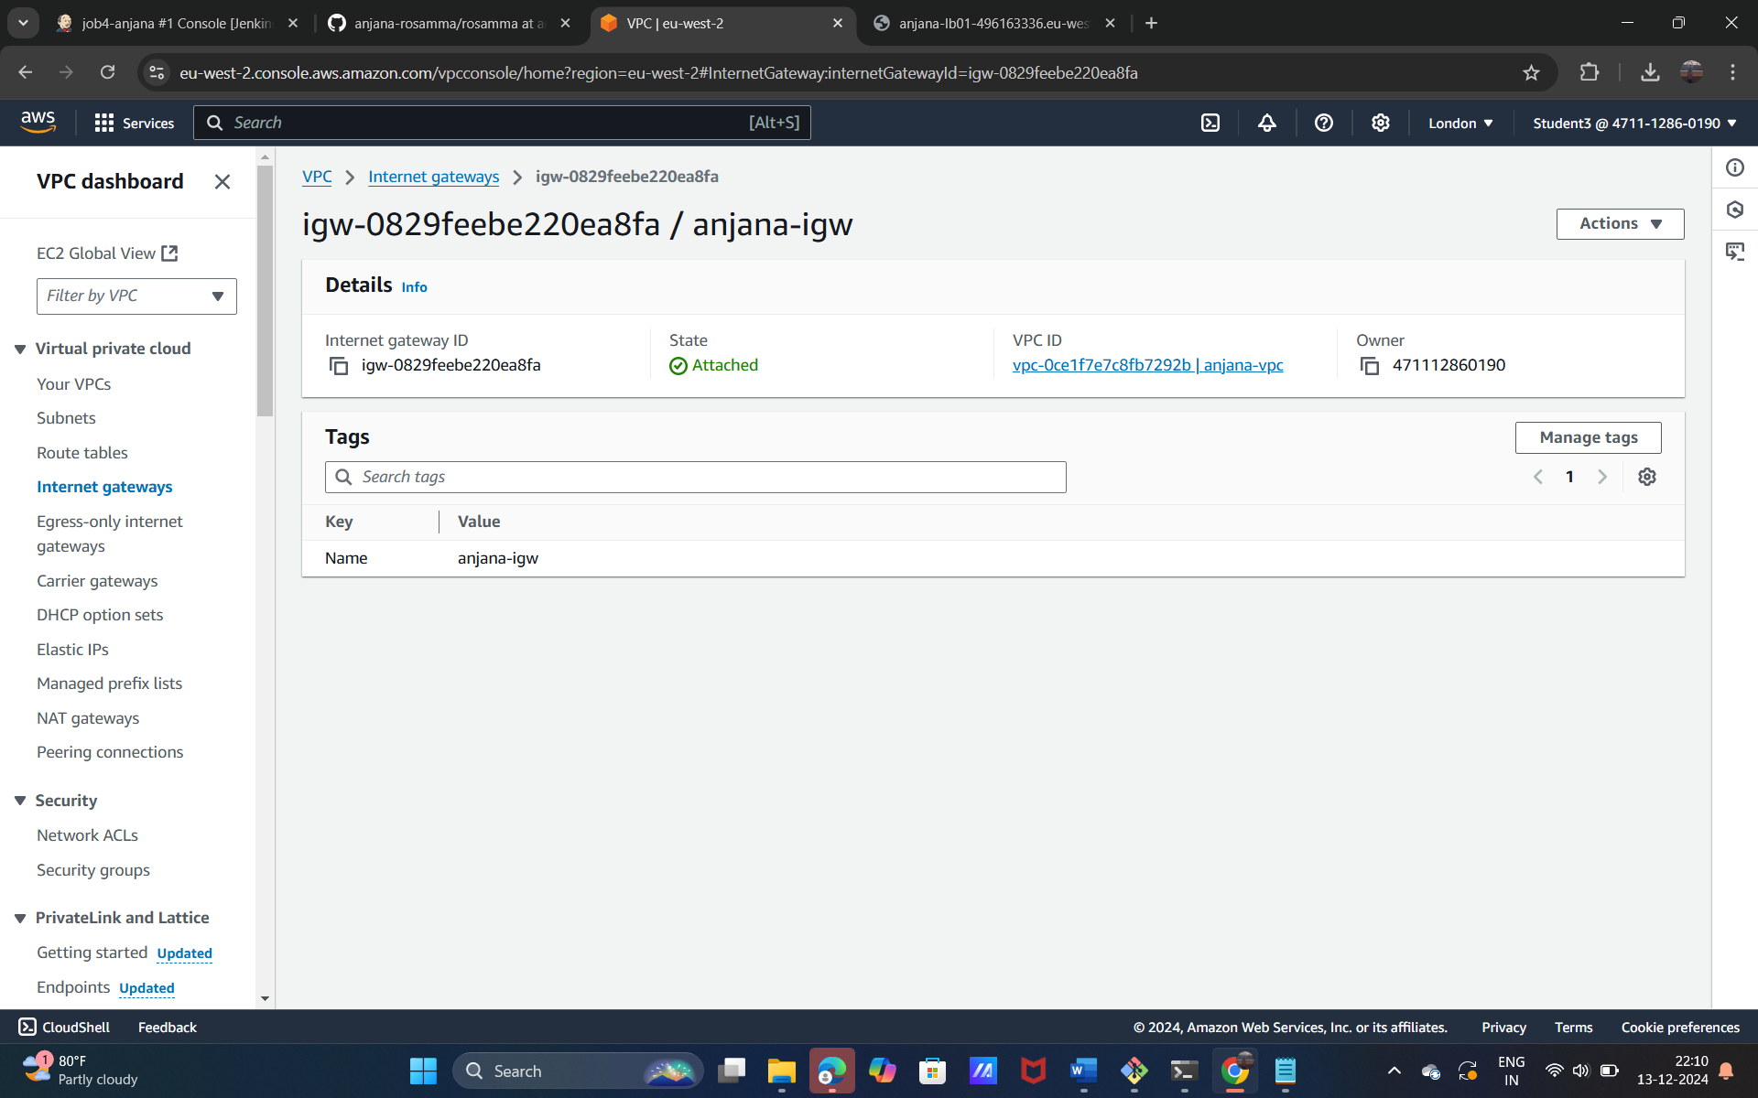

**subnet**

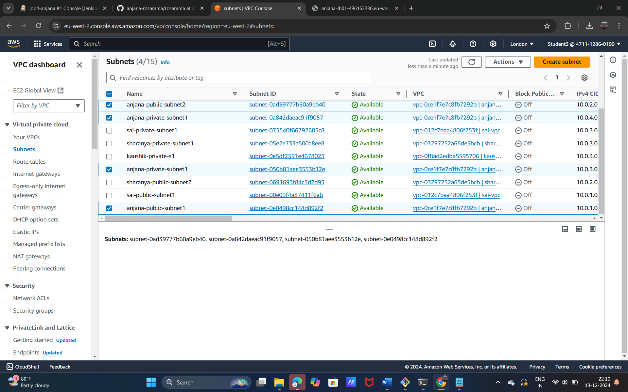

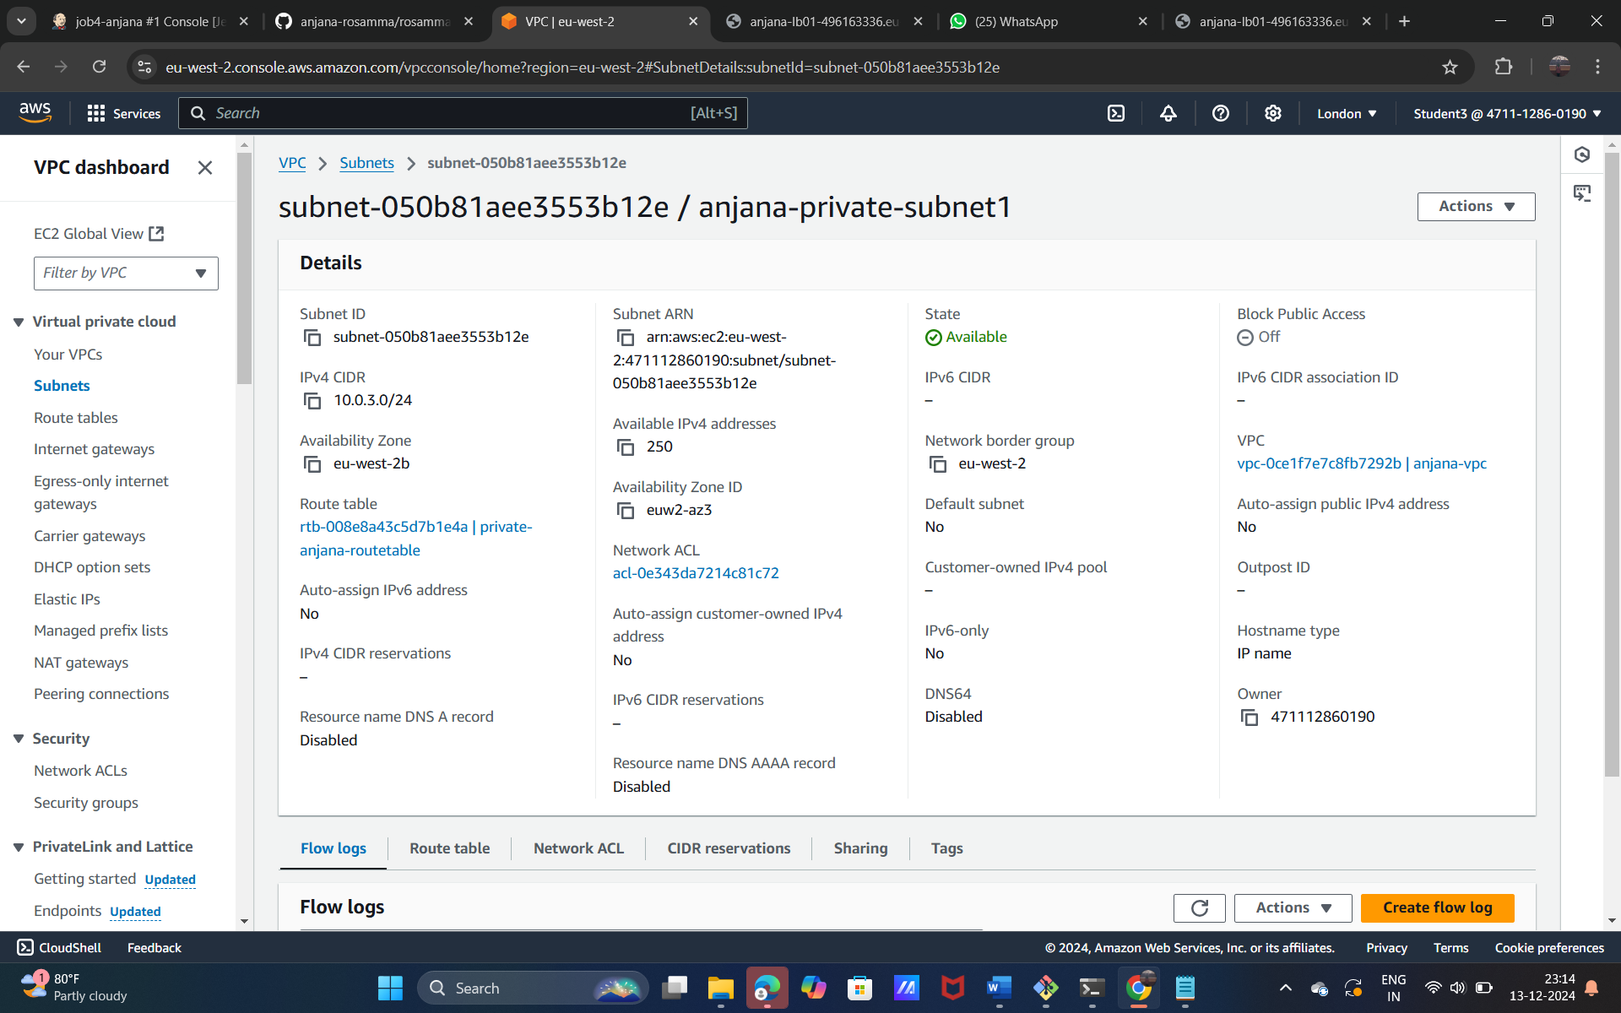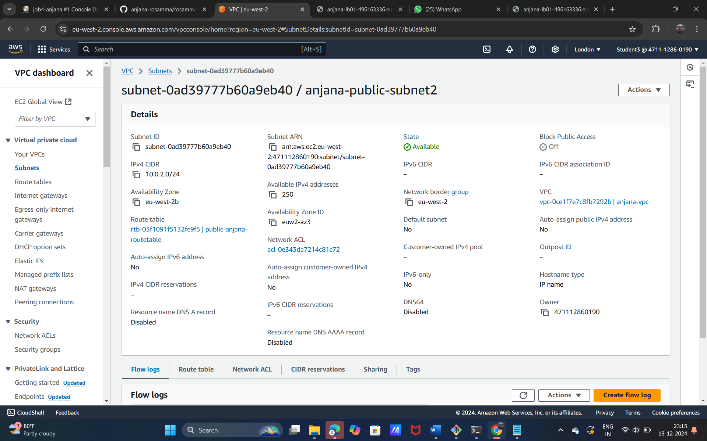

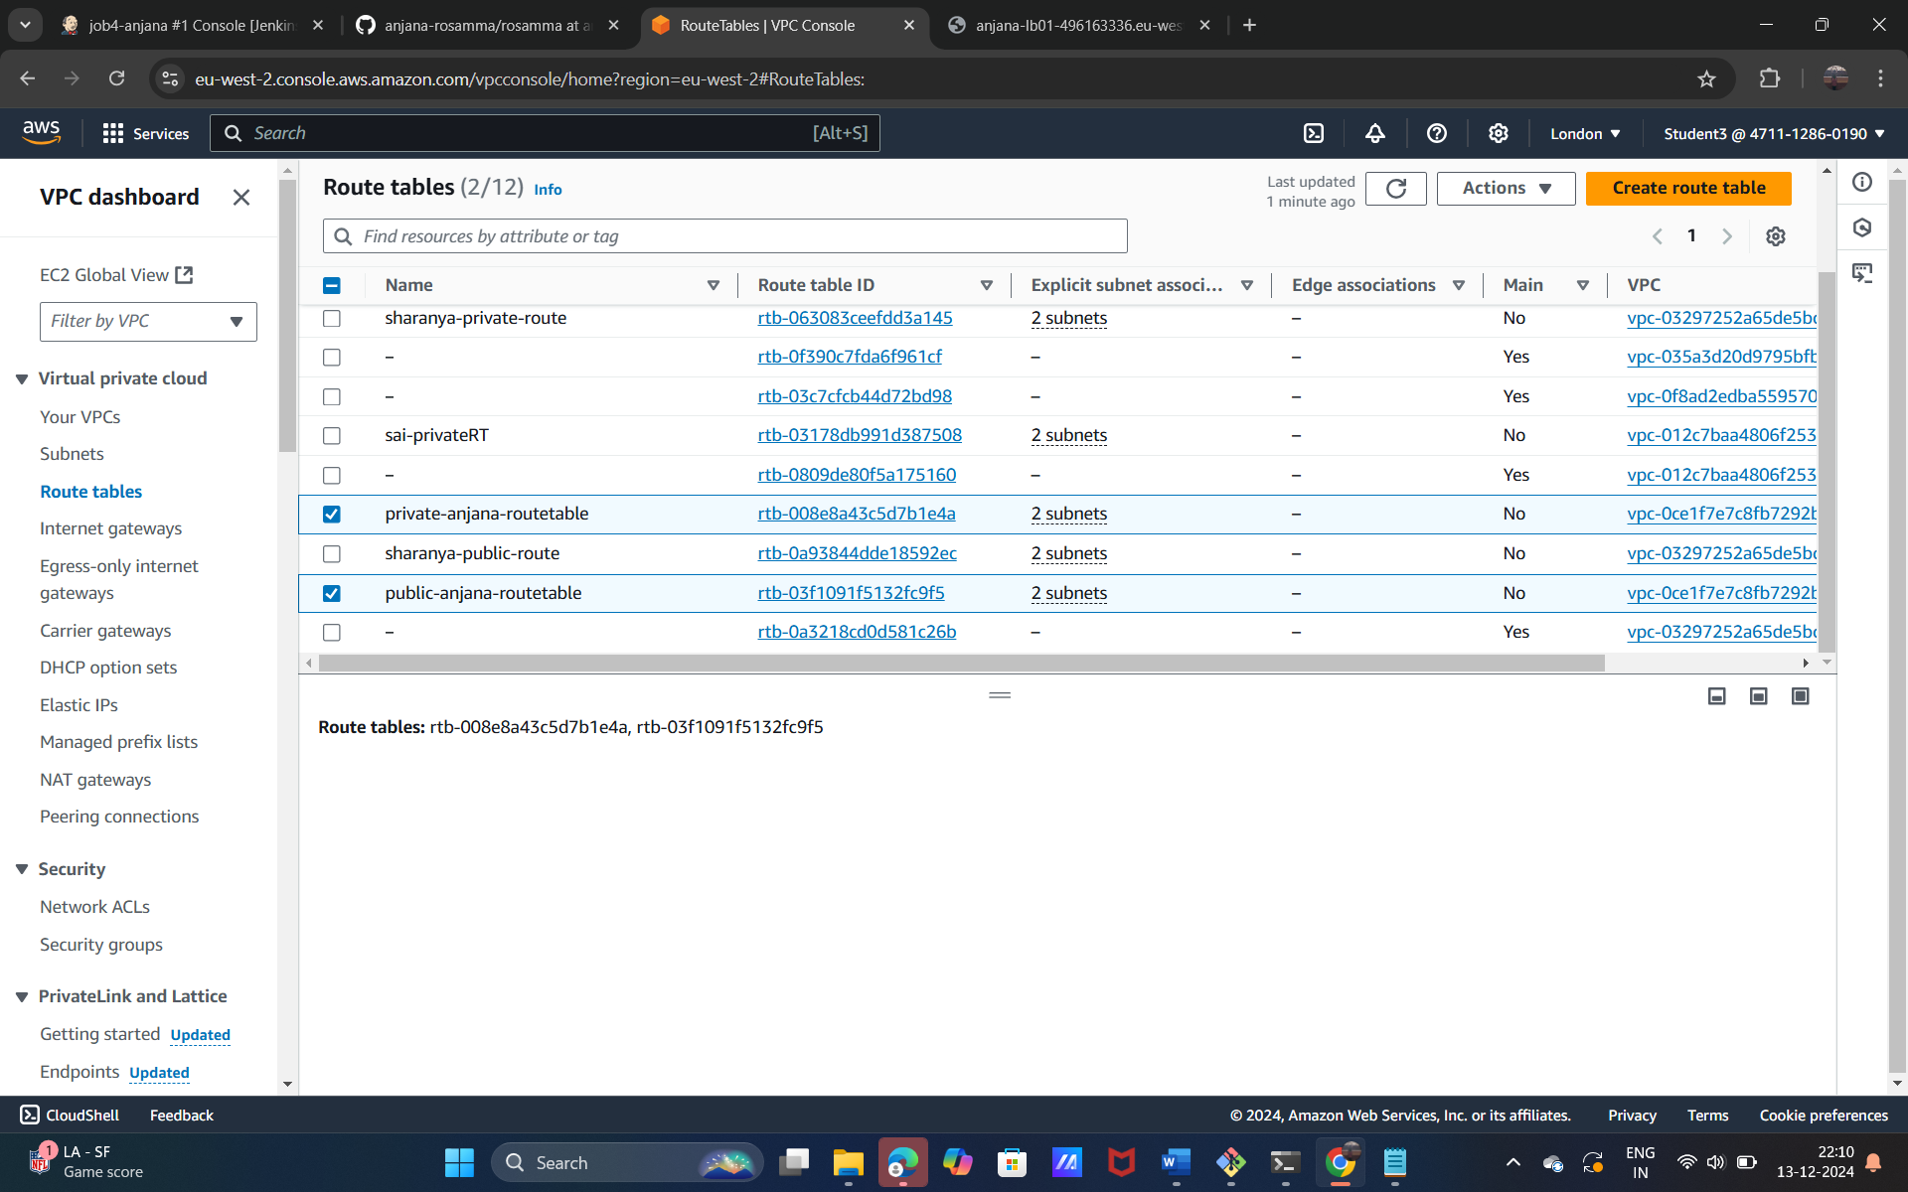

**NAT**

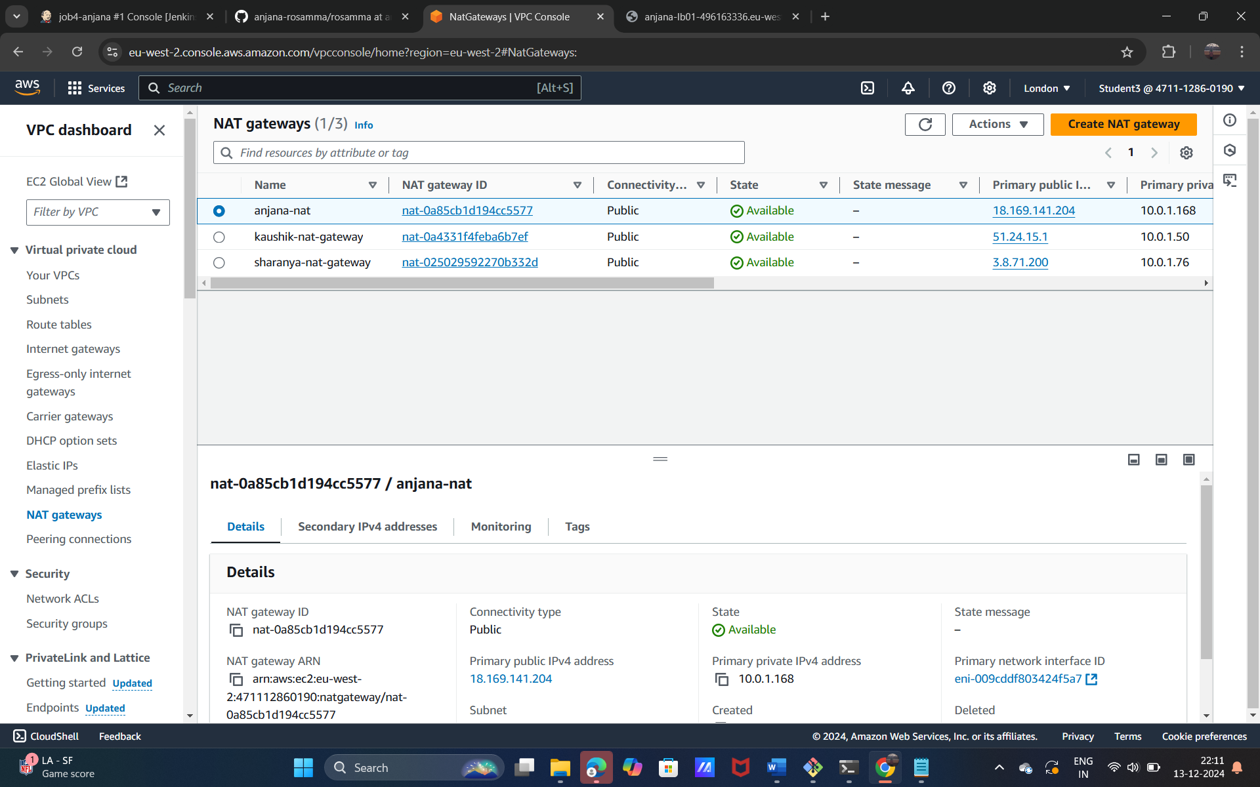

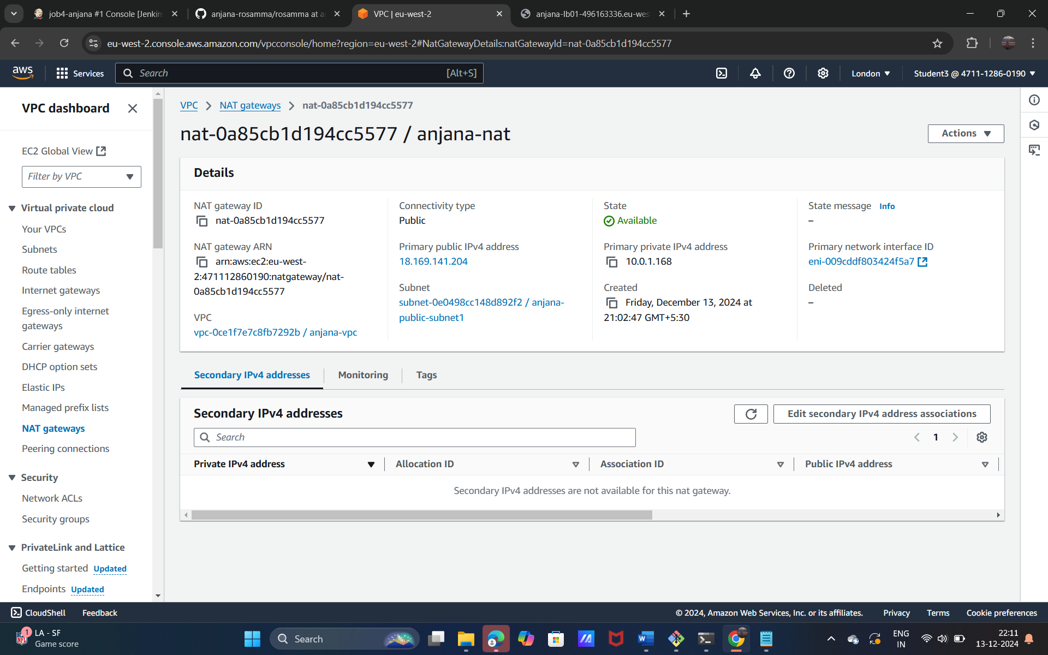

**Load balance**

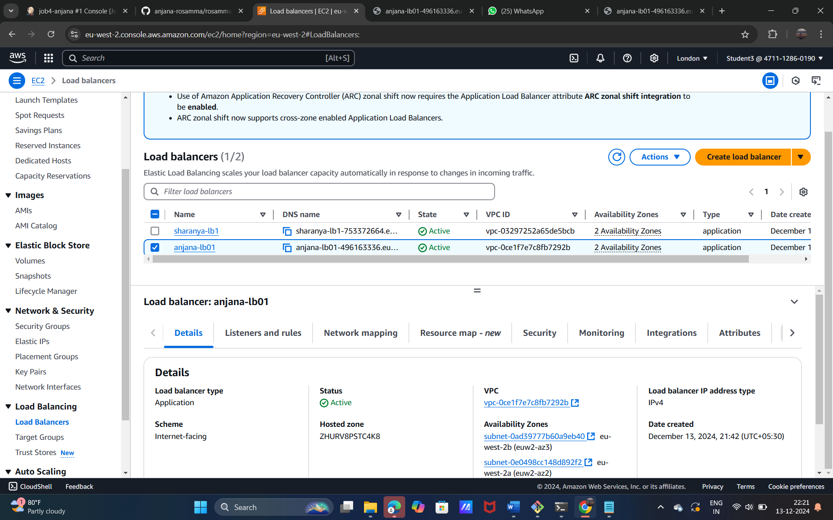

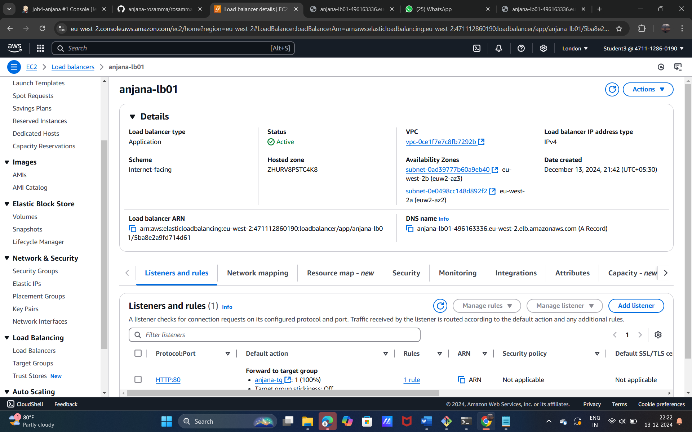

**Instance**

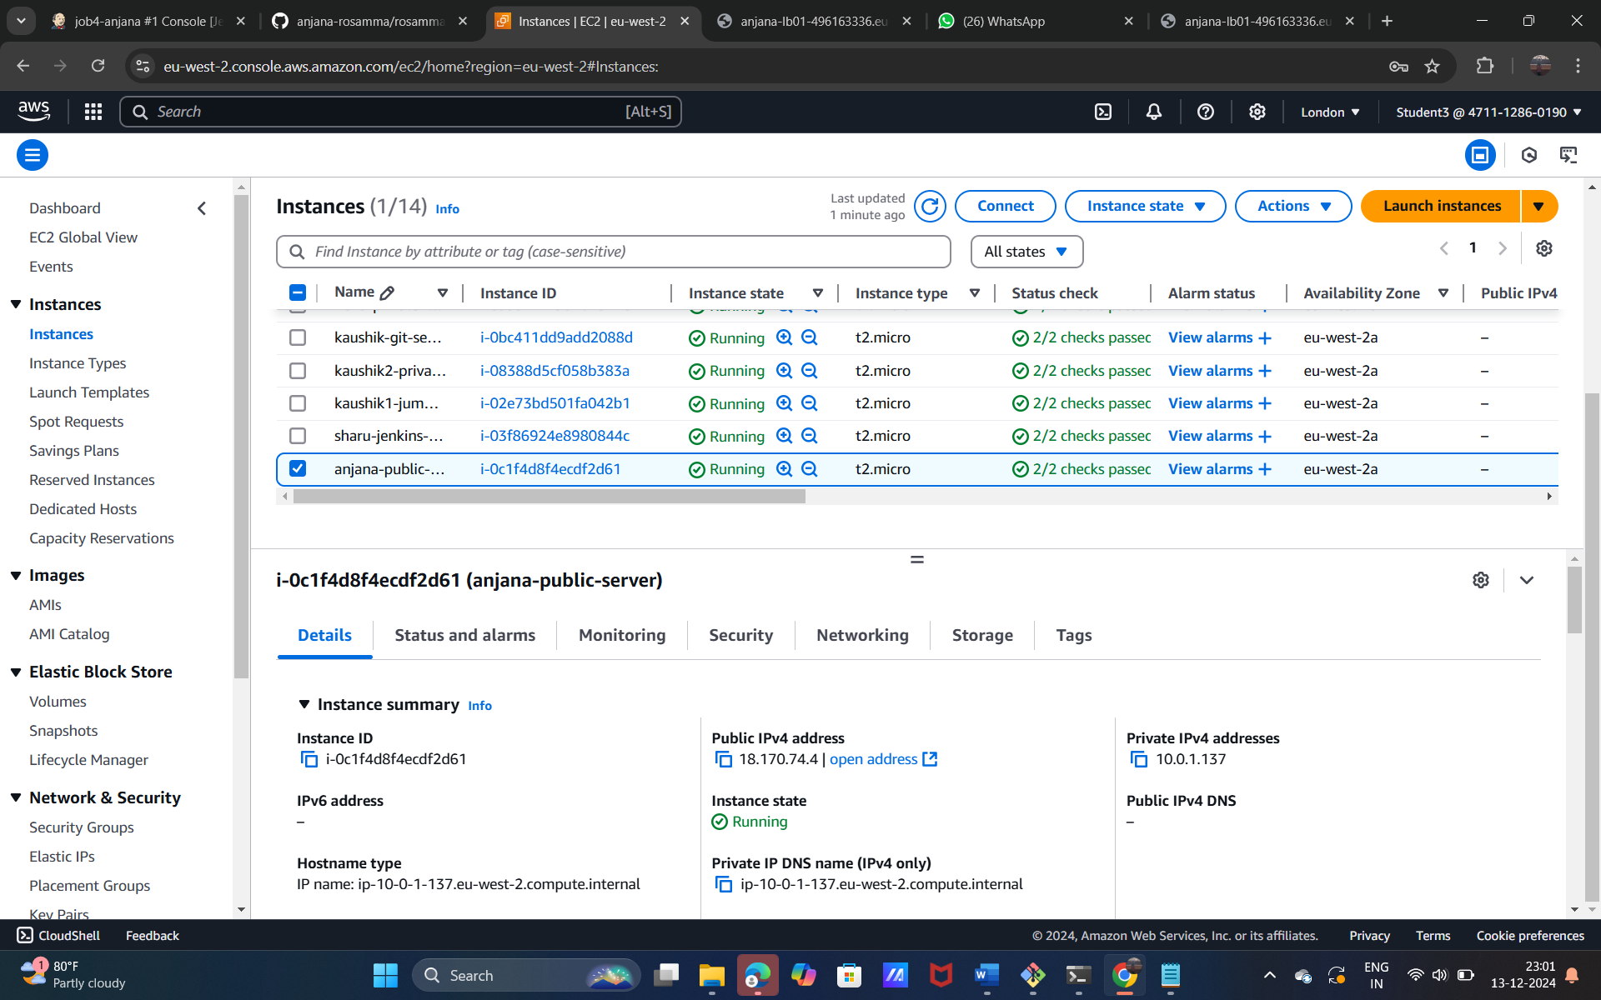

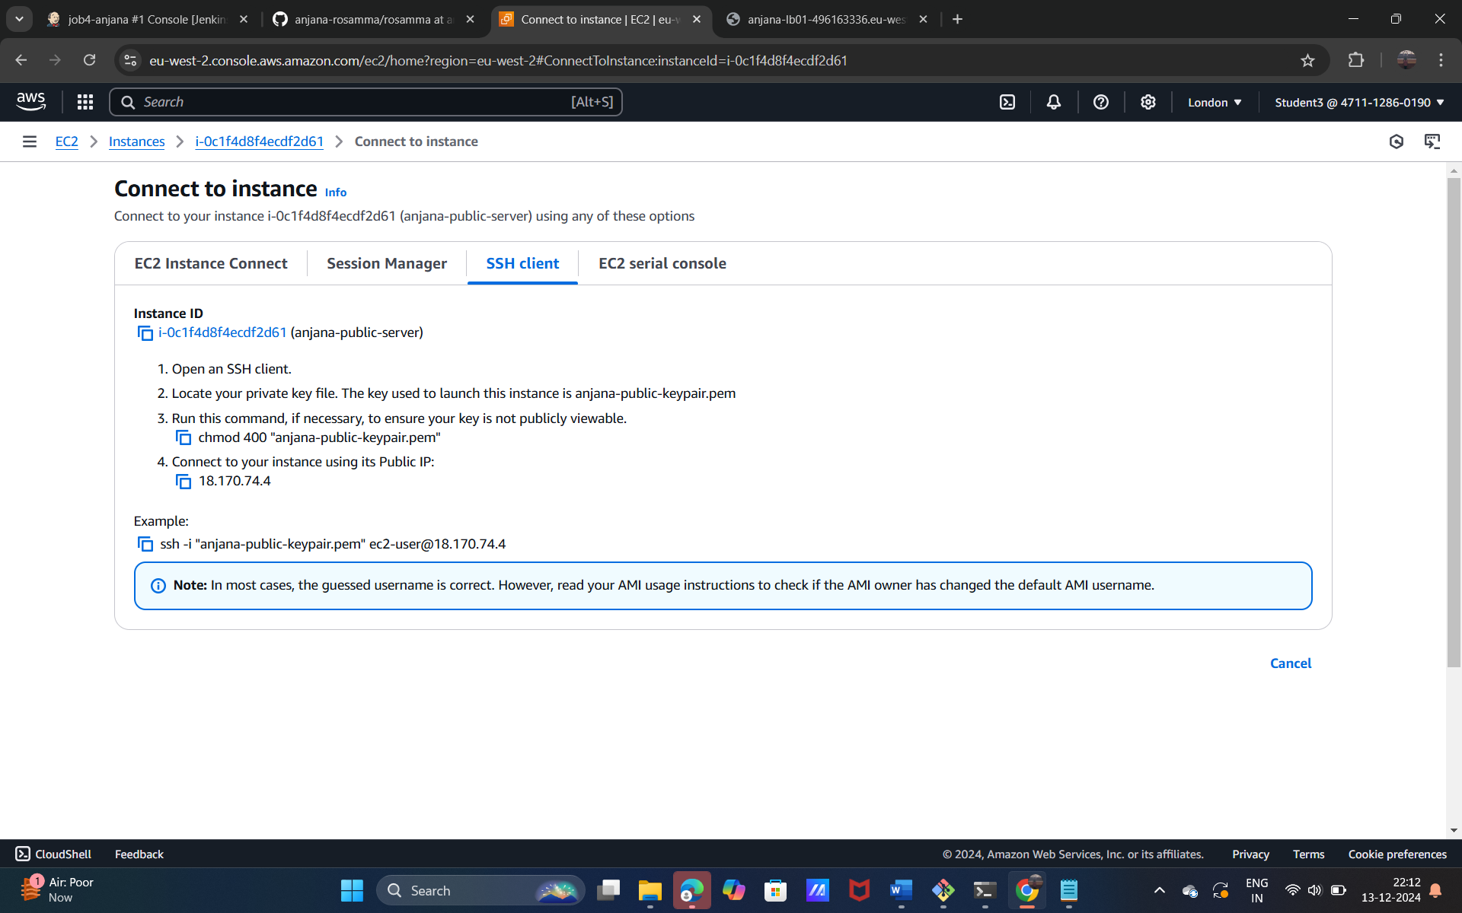

**Command prompt**

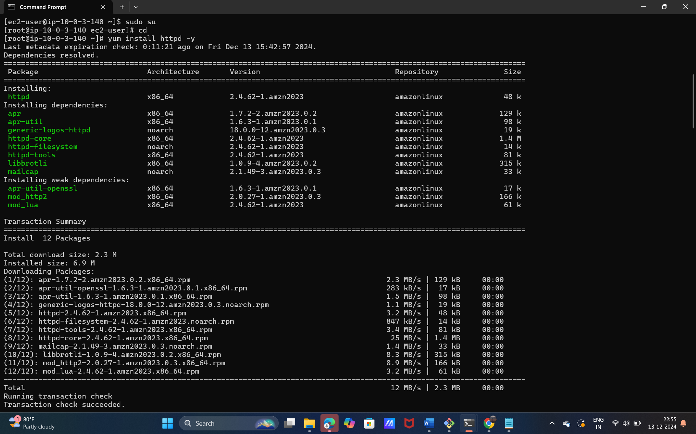

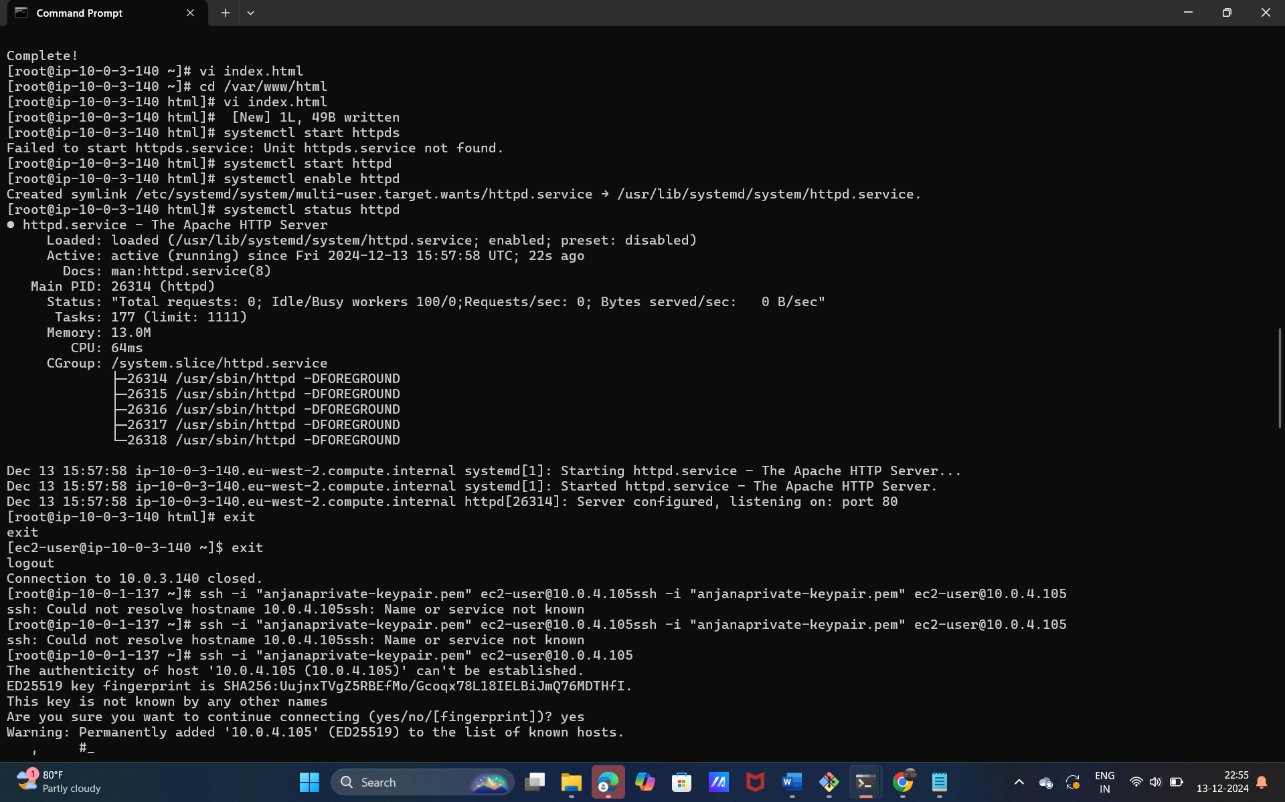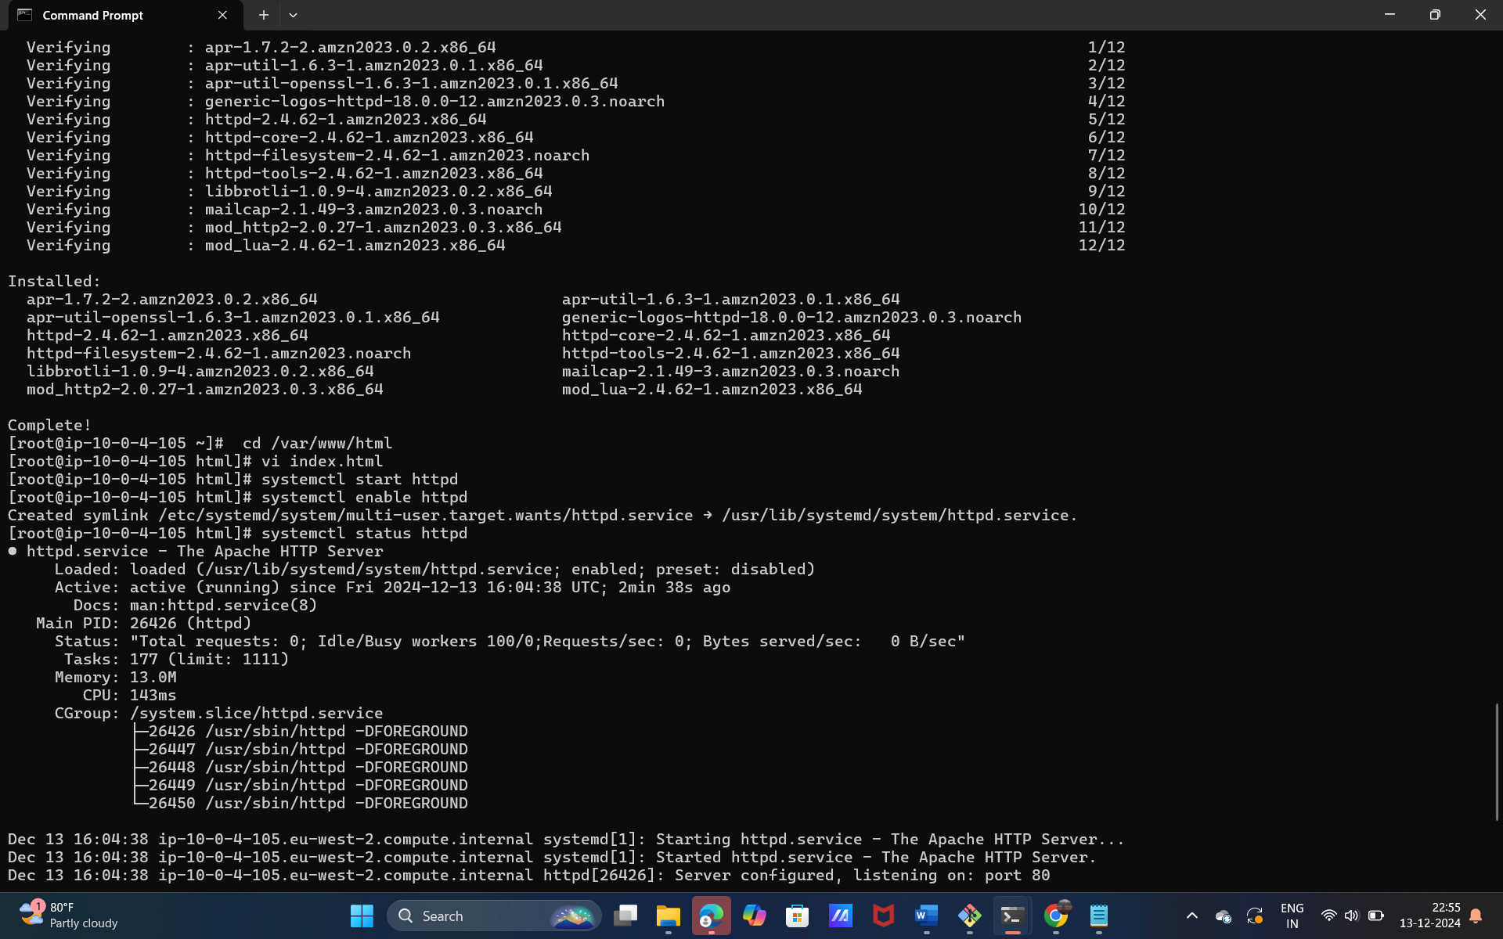

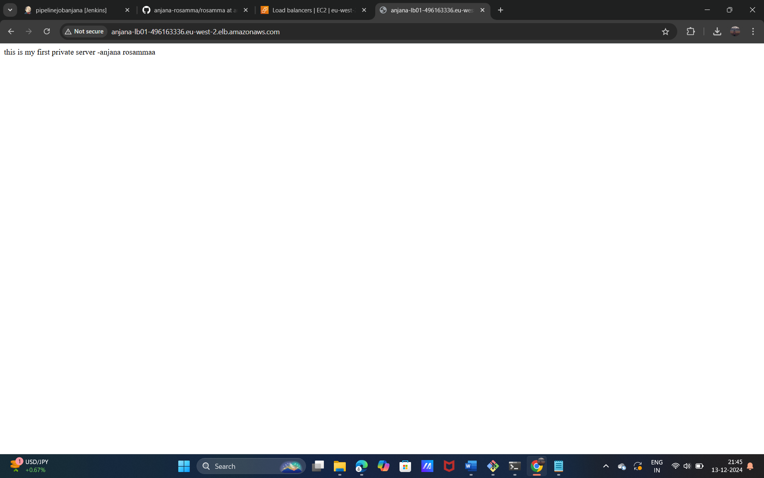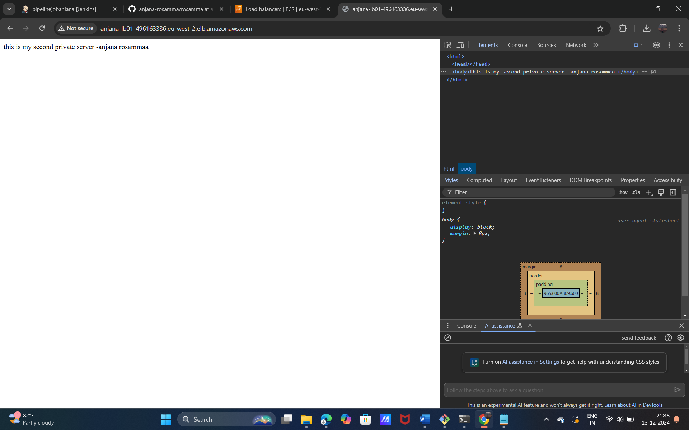

**Project:6**

**How to create Repository in github**

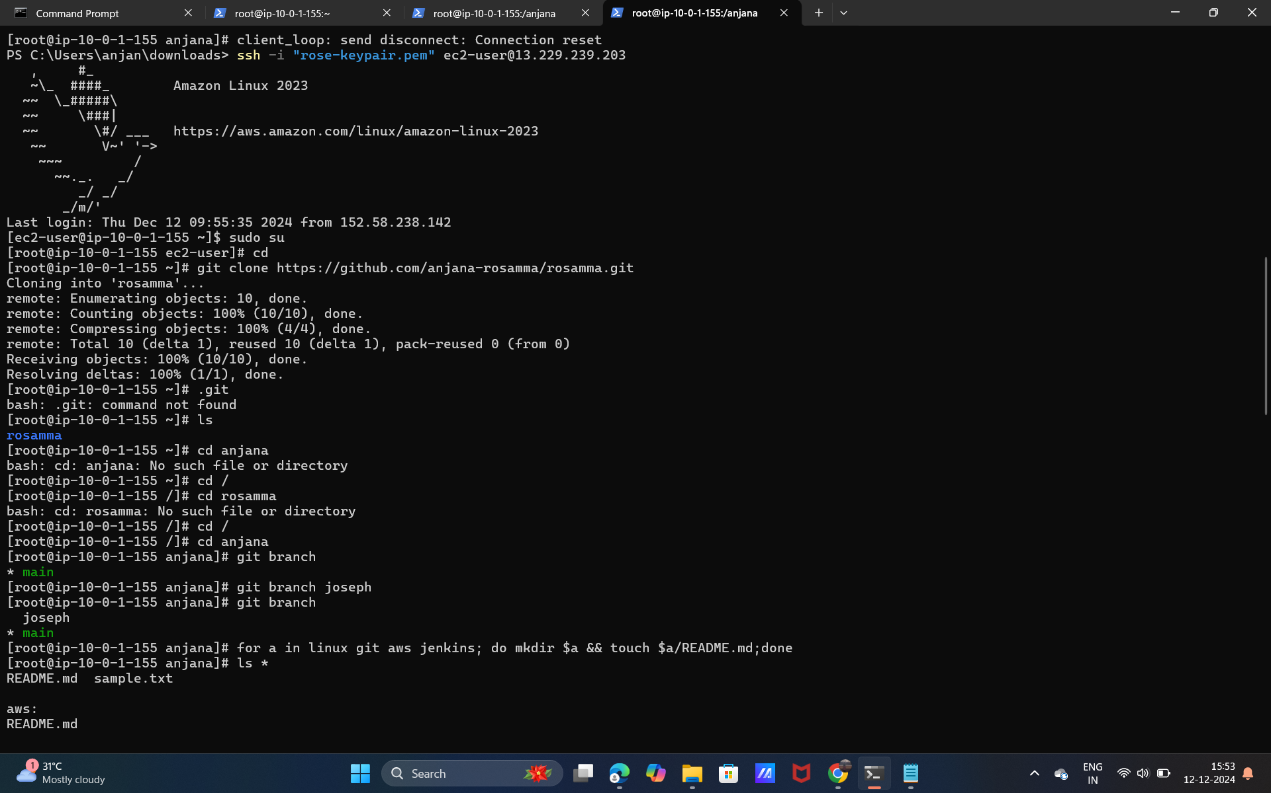

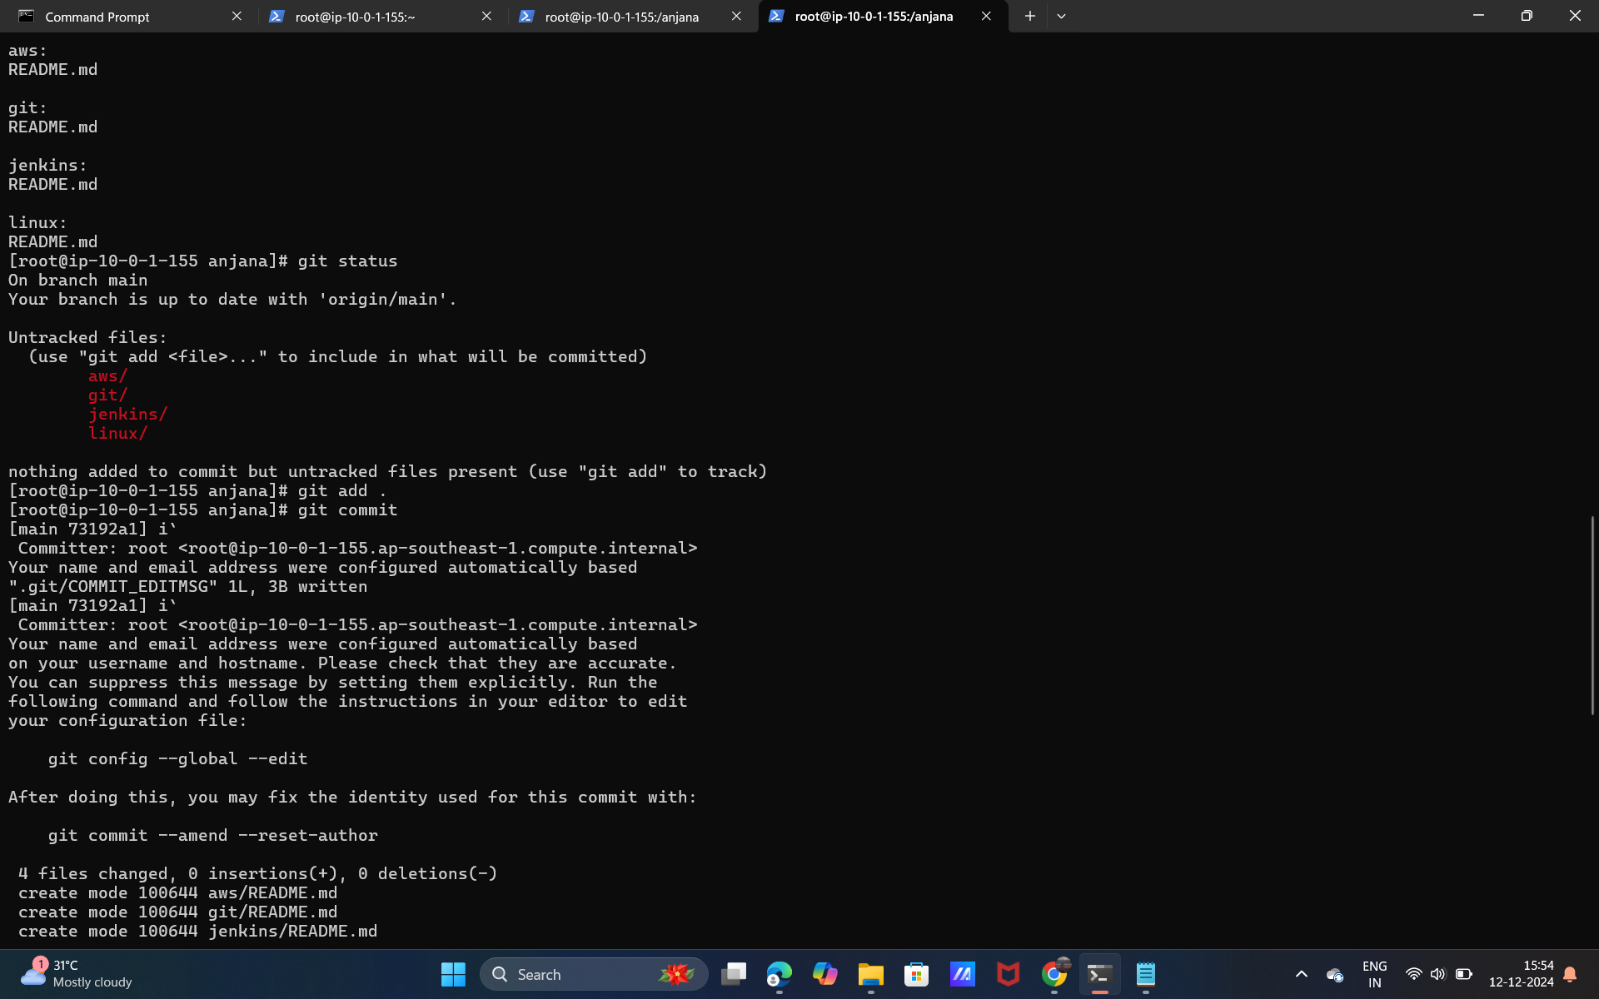

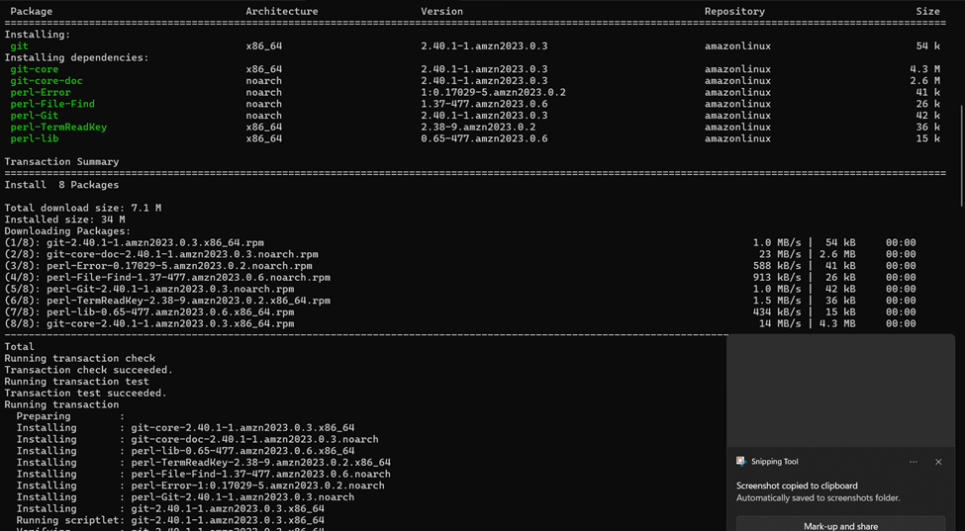

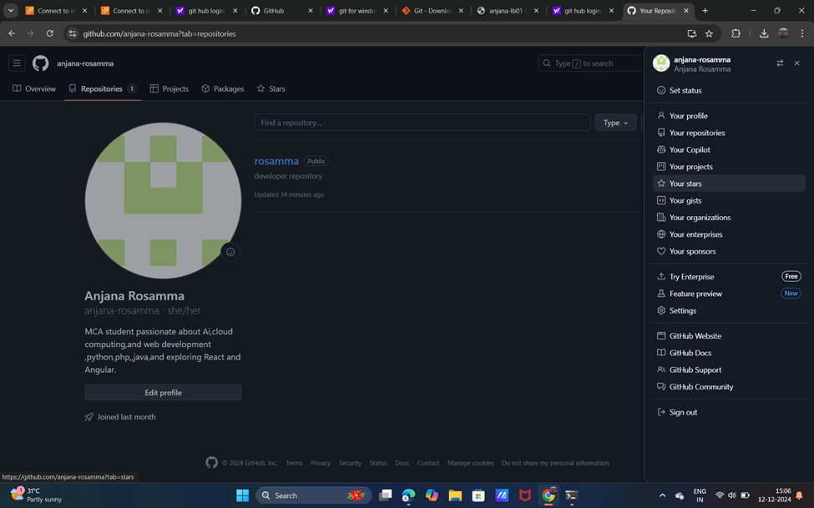

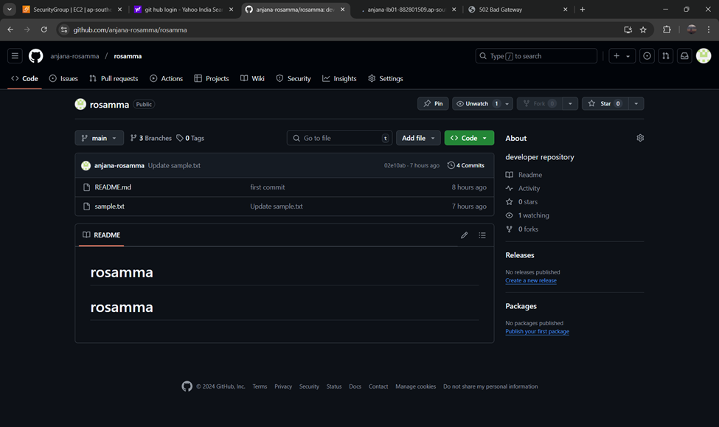

**Project :7**

**How to download and run project from git hub**

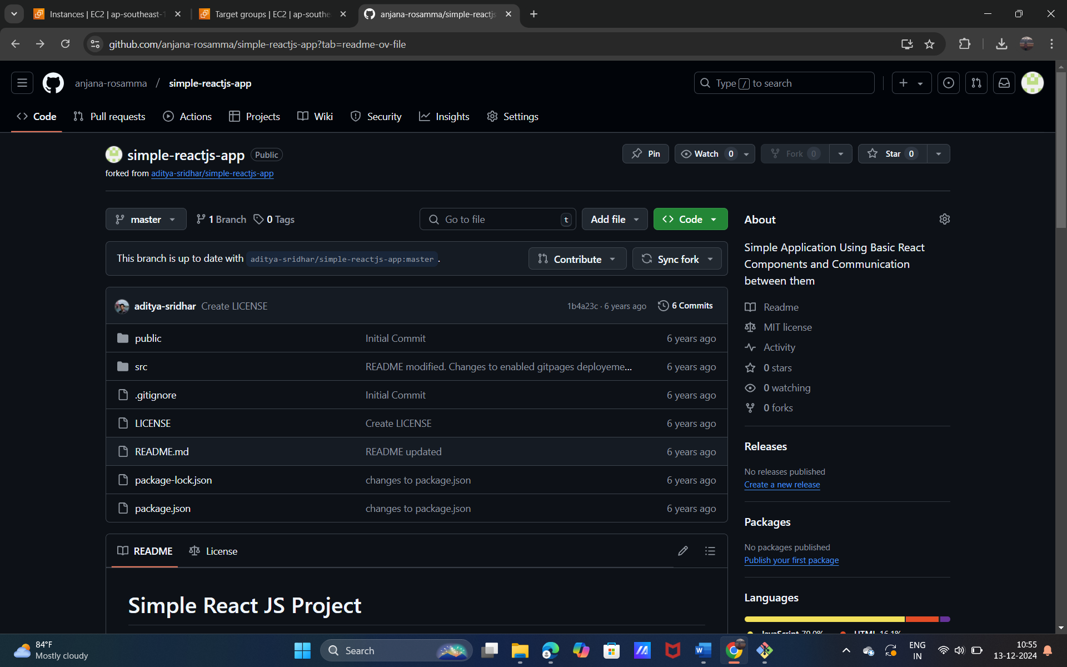

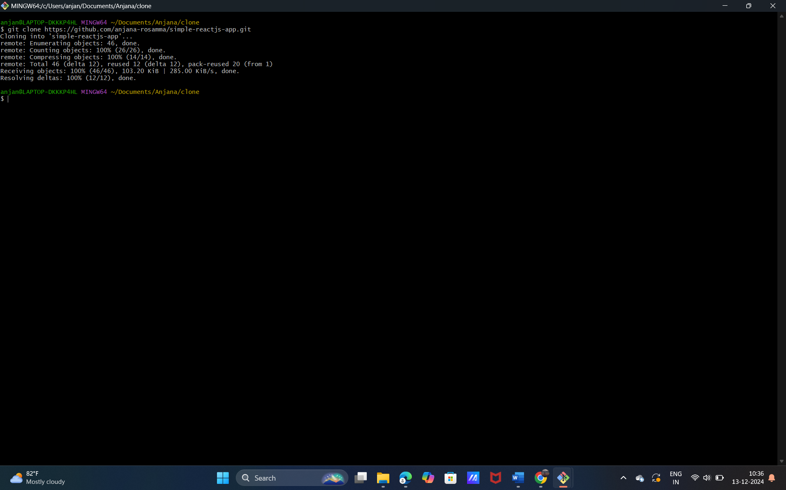

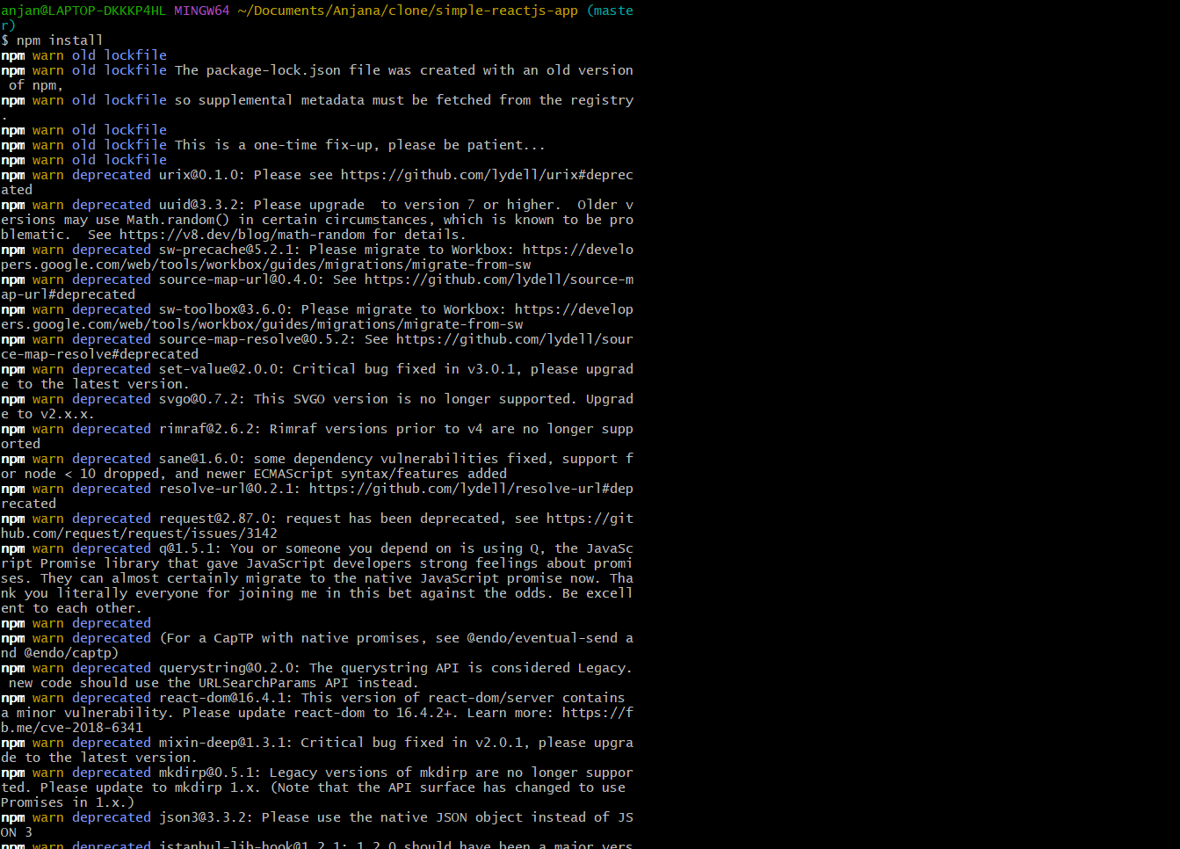

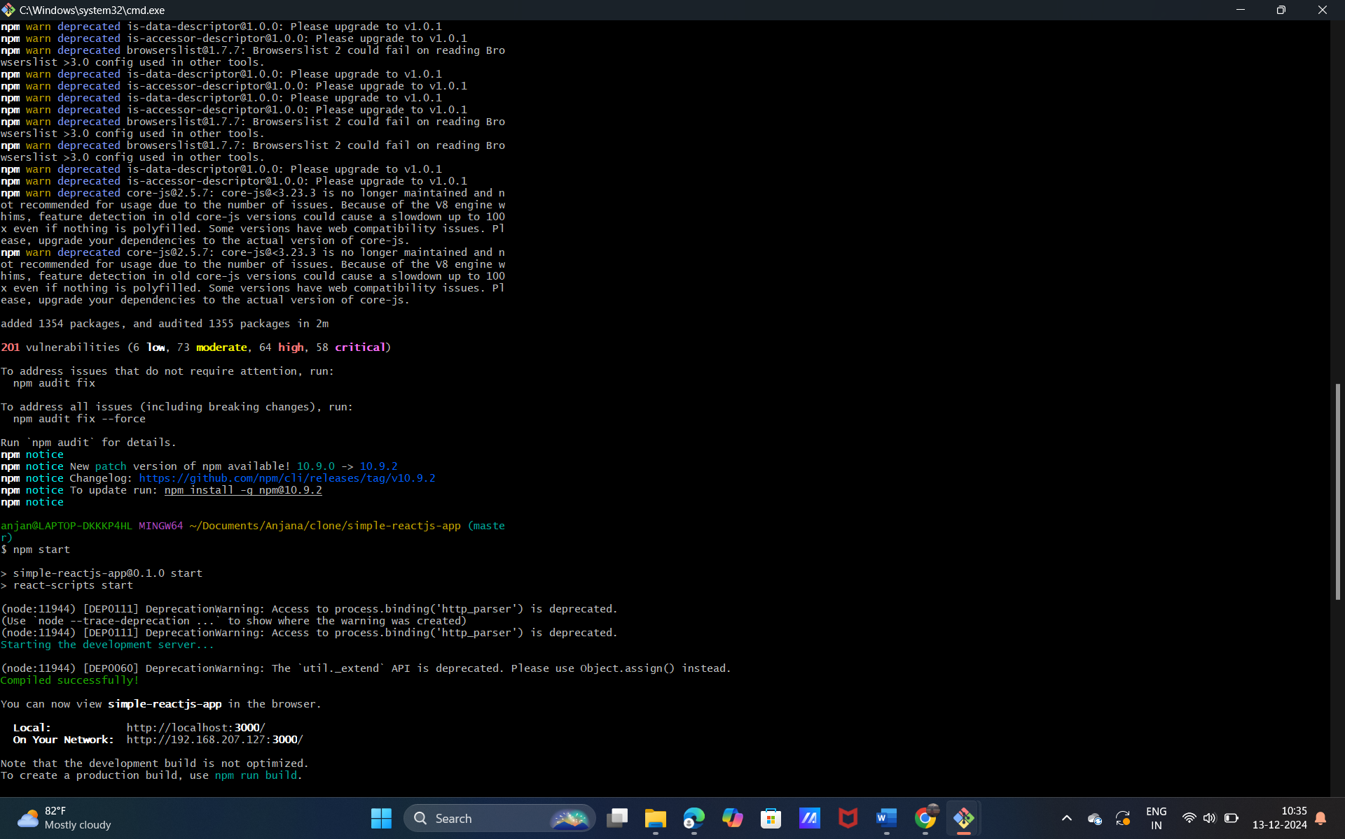

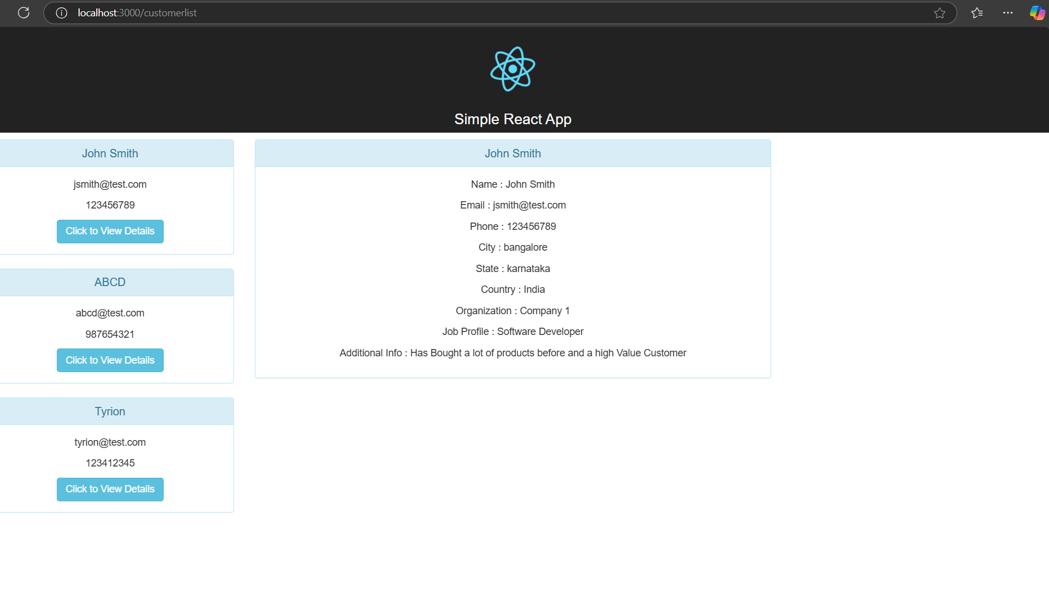

**Project 8: How To Automatically Trigger in Jenkins using pipeline script interacting with the GitHub**

**Creating the job3-anjana:**

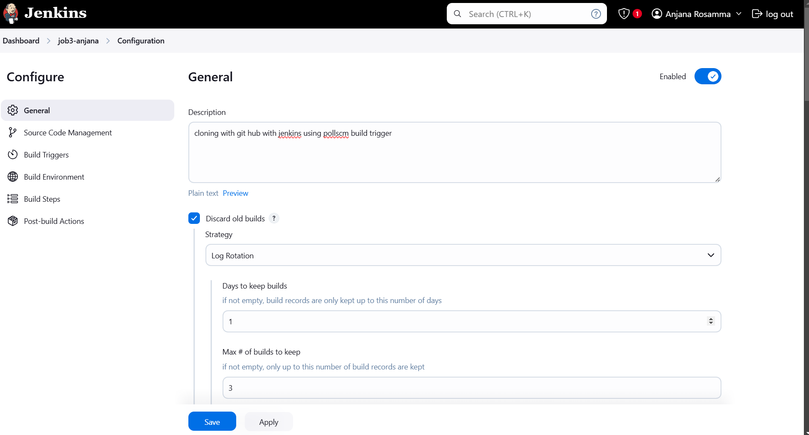

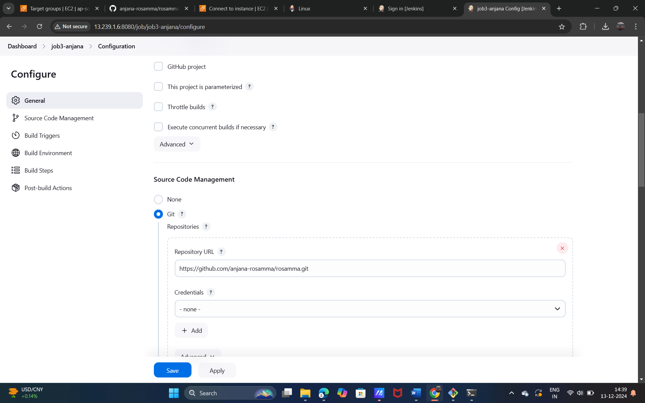

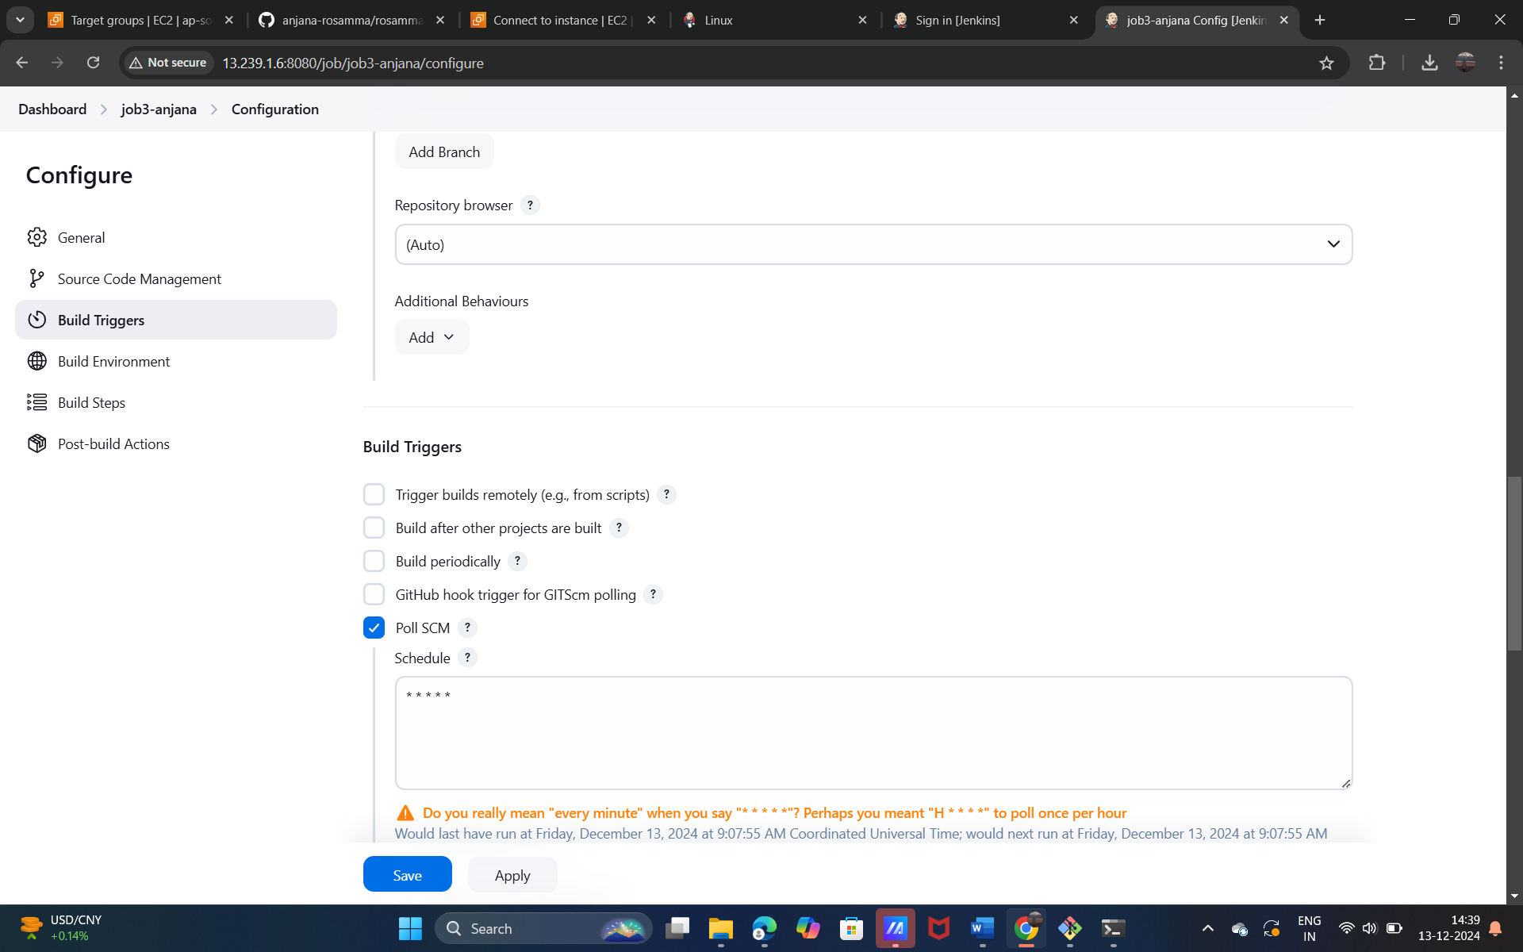

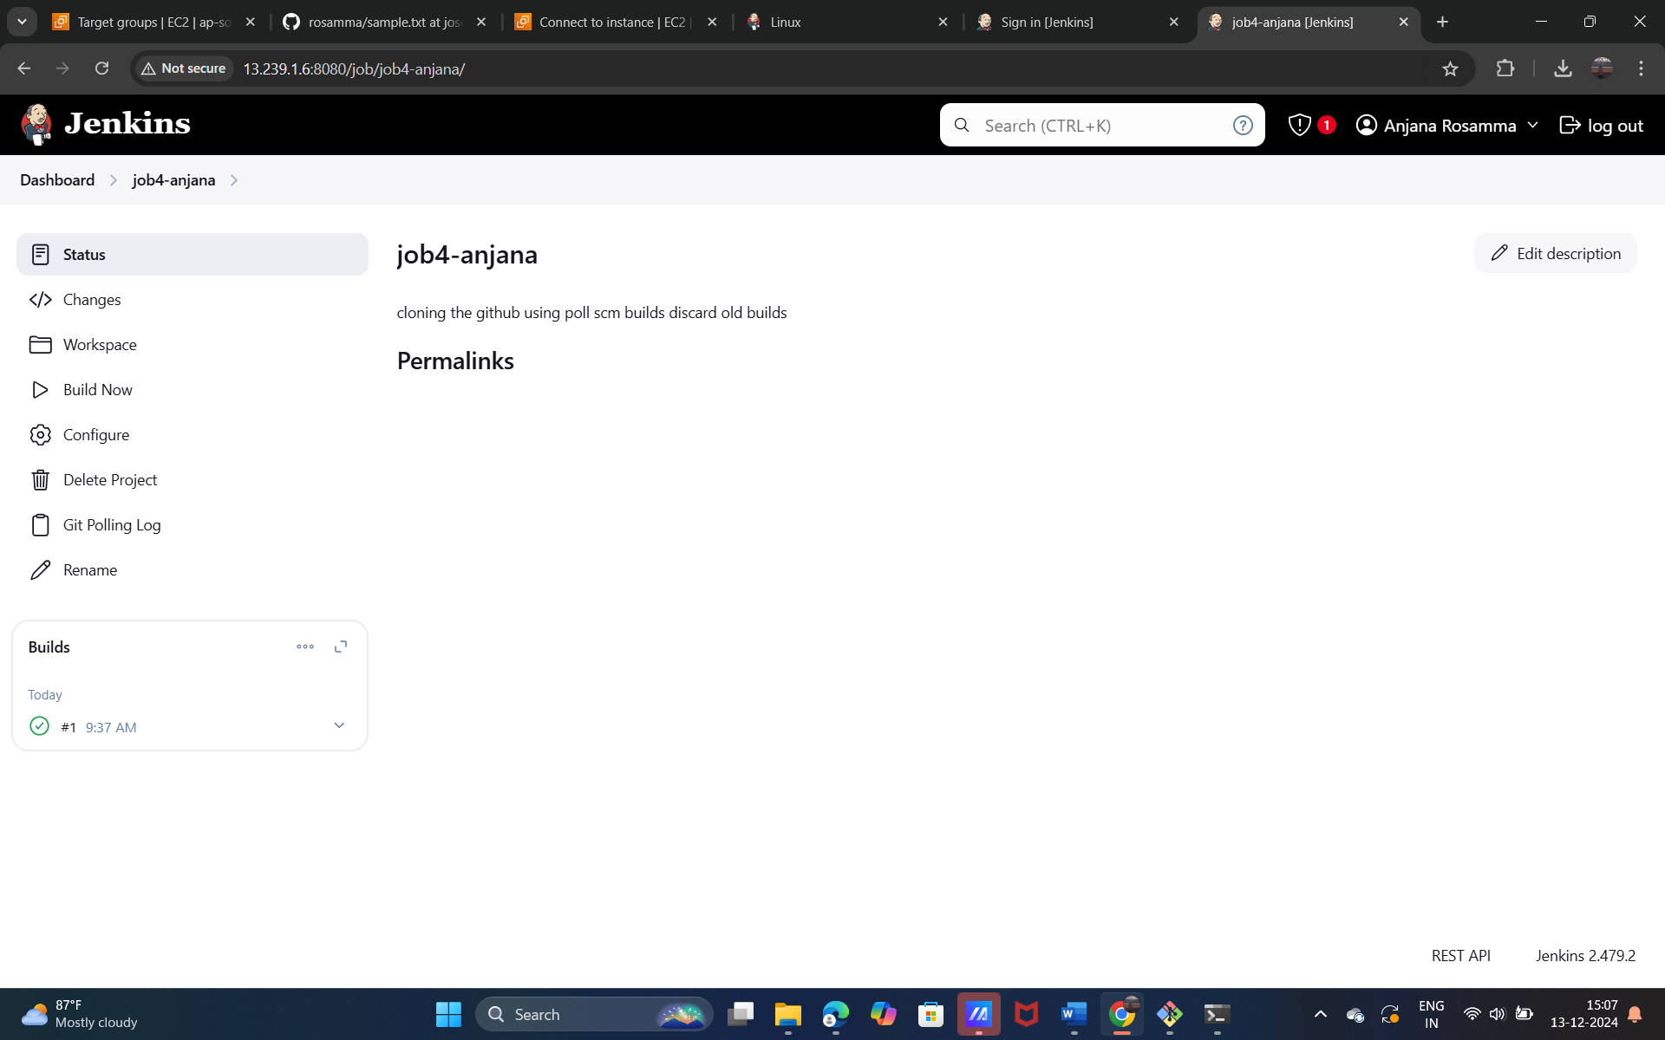

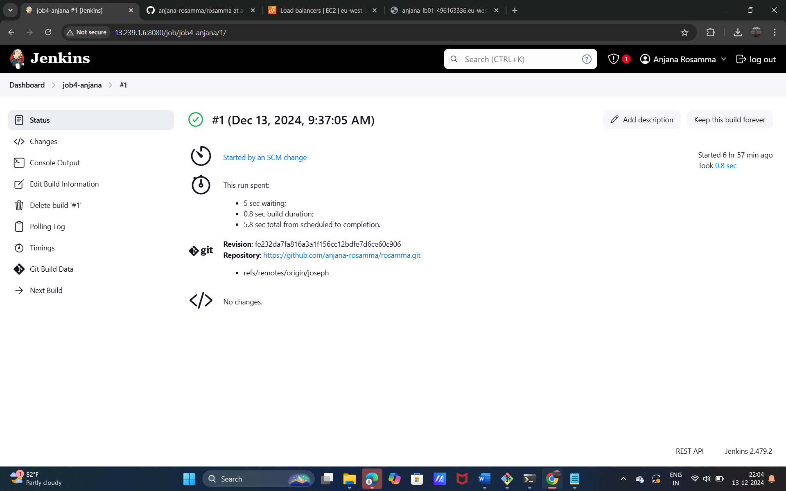

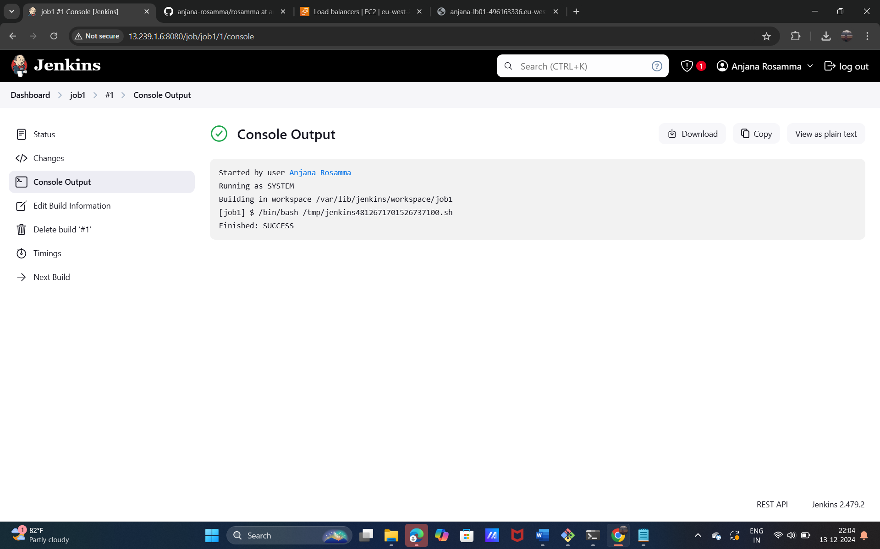

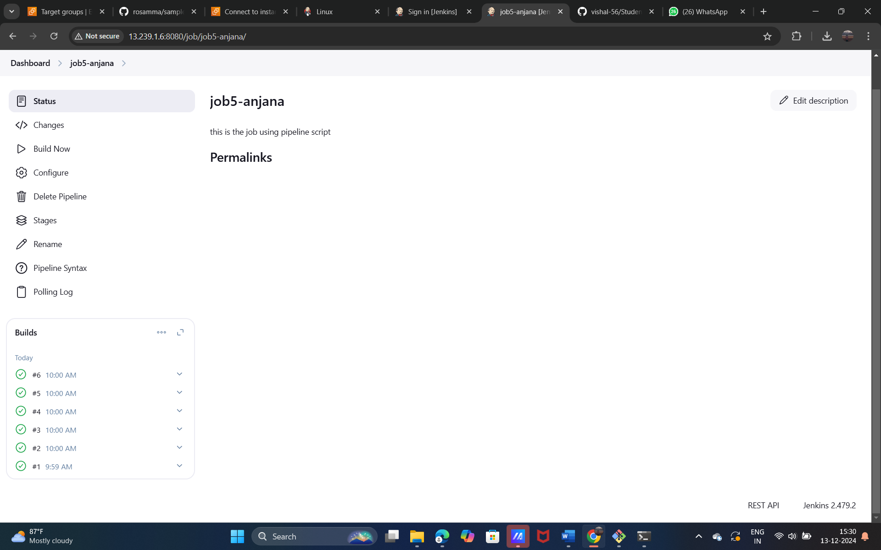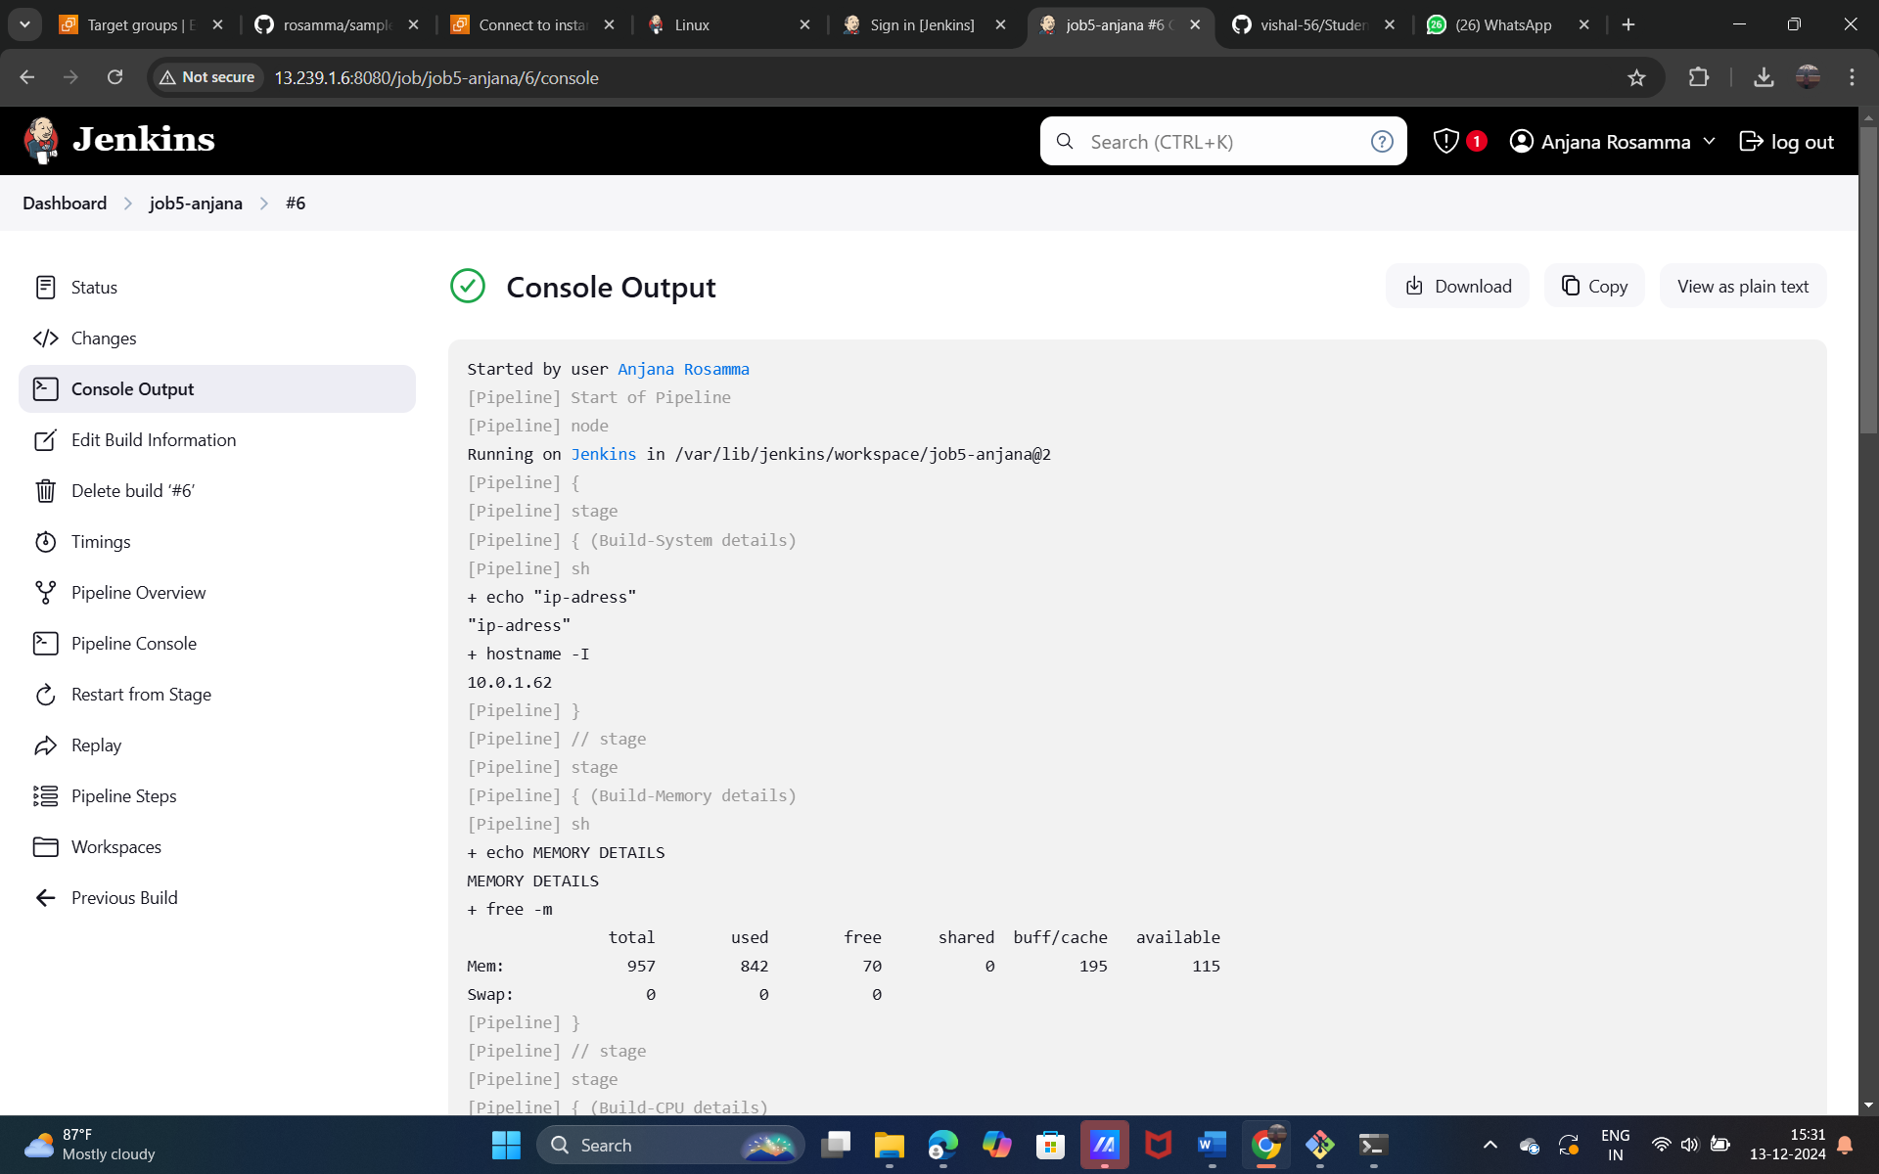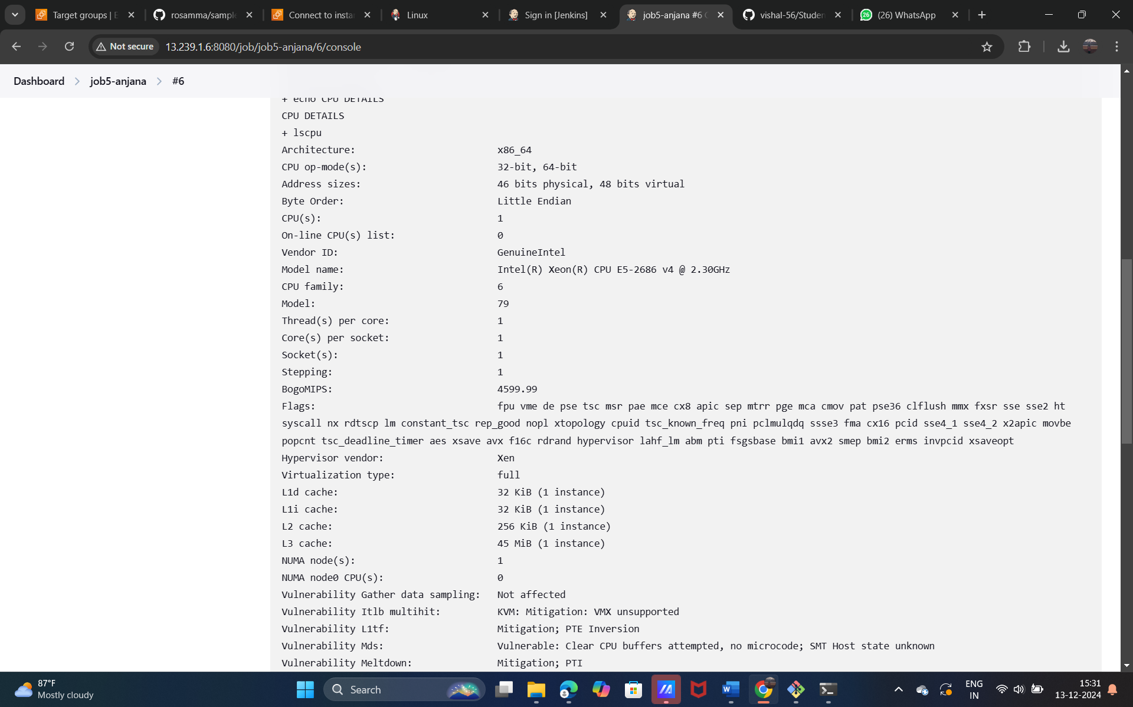

**Project 9: How to Clone with GitHub using Jenkins**

**Creating JOB4-anjana:**

